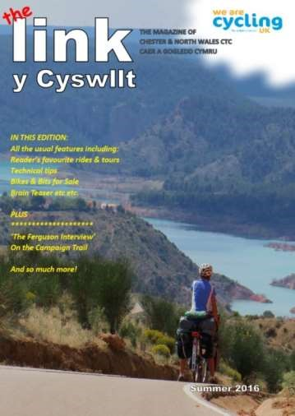

To get their copy of ‘the Link’ of course!

Where else can you read about all the rides

& tours that our local members enjoy, the

bikes they ride and so, so many useful tips on

what makes their bikes ‘tick’!

We also have articles on local
events, local

history, even recipes designed for cyclists!

The magazine is specifically written for the

members of Chester & North Wales CTC by

the members so it’s always a topical read.

Interested? Turn over for a Subs form

Subscription
www.ctcchesterandnwales.org.uk
Dear Rider
Thank you for your support for the Chester & North Wales CTC Caer a Gogledd Cymru. Our topical magazine ‘The Link’ is available to all members and friends and represents the needs of the membership by means of membership participation. It’s their voice and ‘The Link’ depends on the member’s interests, experiences and needs to continue the successful history of the publication.
Be part of it; please complete the form both for renewals or new subscribers so we can all share in the opinions and items which interest you. All contributions are welcomed whether hand written, electronic or emailed because they come from cyclists for cyclists so let’s continue your valued support for the Club’s important magazine – your magazine!

Address:

Name:

Post Code:

Email:

tick box(s) to select

✓

Please renew my subscription for THREE copies of ‘The Link’ including postage
Paper copy mailed to your address? Email version (pdf)? Other format?
£12.60
THREE COPIES: Donation – to subsidise ‘The Link’: £ Total: £
I agree to the above information being kept on an electronic database only for C&NW CTC purposes:
Signature: Date:
Payment Methods
Cash: Cheque: (payable to Chester and North Wales CTC) Standing Order:
Bank Transfer: (Sort code: 60 40 08 - Account number: 32899807)
It’s really important on all payments especially Standing Orders and Bank Transfers that this following reference is added to your Bank details………… ‘Link + your post code’. Without this reference we won’t know who’s paid! Any cheques should be made out to ‘Chester and North Wales CTC’. Please send all subscription forms and cheques (where applicable) to:-
Graham Arnold “Riponhurst” Pikey Lane, Gresford, Wrexham. LL12 8TT
Please email link@ctcchesterandnwales.org.uk if you have any concerns or questions.

