CTC DUMFRIES AND GALLOWAY
AGM
TUESDAY 12 NOVEMBER 2019
GALLOWAY WOODTURNERS WORKSHOP
ABERCROMBY ROAD INDUSTRIAL ESTATE, ABERCROMBY ROAD
CASTLE DOUGLAS, DG7 1LH

MINUTES:

PRESENT: As per signing list

- Welcome
Bob Rostock welcomed the attendees.

- Apologies
Sandy McGlashan
Tom Hanley

- Minutes of previous AGM
Minutes read and accepted.

- Matters Arising
To be discussed during meeting.

- Chairman’s Report
Bob presented his review of the year – please see attached report.

- Secretary’s Report
To be discussed under AOB.

- Treasurer’s Report
Ted advised that the group must be seen to use the annual funds allocated to all member groups by Cycling UK. Please see attached report for current balance and spend.
Read and accepted.

- Election of Officers and Committee:
Chairman: Bob Rostock Proposed: Ted Norfold Seconded: Deb Merrick
Treasurer: Ted Norfolk Proposed: Bob Rostock Seconded: Jim Cowan
Secretary: Debbie Merrick Proposed: Phil Howard Seconded: Bob Rostock
Webmaster: Tom Hanley Proposed: Seconded:

Committee:
Sandy McGlashan : David Assinder : Robert Bealby : Doug Oberheim : Jim Cowan
New members:
Esther Tacke: Ian Gilbert

- Sportive Events
Rotary Clubs held Sportive events throughout the region in aid of Prostate Cancer. Ted was invited by Newton Stewart Rotary Club to present to them how operate a Sportive event. Bob, Betty and Phil were invited along too, to help with the organisation and it turned out to be a very well-supported event. Betty and Phil have subsequently been asked to assist with the organisation of the 2020 event. First planning meeting has not yet taken place however.

- Ride Programme
The perennial problem of Ride Leaders turning up at the meeting place to discover no riders had attended. It was discussed how to get in touch with people to advise dates and times. Social media is an instant platform for getting messages across, with perhaps WhatsApp groups / Facebook messenger as well as using Facebook pages to achieve communication in an effective way.

Bob also commented that Cycling UK have an active member group page which we should use to promote activities in the area. He asked all Committee members to look at the page, see what other groups are doing and if there are any suggestions, please pass them to Deb. These will be discussed at the next Committee meeting.

- Annual dinner
Sunday 2 February 2020, 12.30 for 13.00 at the Selkirk Arms. Bob will contact Chris Walker at the Selkirk Arms to book a date and arrange menu and costs.

- AOB
After the previous AGM it was decided to take space with VisitSouthWestScotland (VSWS), the annual subscription is £60. This is due for renewal. The Committee discussed the effect taking a subscription had had for the group.

Unfortunately, funding is being withdrawn by the Council to VSWS, they must rely (at least for the foreseeable future) on raising funds from local businesses etc. Funding is available from the Government via South of Scotland Enterprise Partnership (SoSEP) but this depends on VSWS liasing with Scottish Borders Tourism. Also, VSWS seem to be focusing all their attentions on promoting SW300 driving route.

The Committee revisited the suggestion from last year’s AGM of producing a leaflet. Esther (Galloway Cycling Holidays), who had joined the meeting has produced a leaflet which was shown to the Committee and it was suggested that the Committee co-operate with Esther in producing a leaflet that would promote rides in the area and which would potentially reach a bigger market place than VSWS (finding CTC D&G is very difficult on VSWS webpage).

Support from other agencies could be obtained, for example UNESCO Bisophere Reserve who are keen to promote cycling; the Pilgrims Way is an under-used opportunity for cycling too.

Esther, through her extensive travels on a bike advised that maps in Europe are very popular with people willing to purchase the maps in order to discover the areas they are cycling in.

Esther was also able to advise the Committee platforms that they may consider when achieving maximum coverage for cycling in the area. DGWGO (Dumfries and Galloway What’s Going On), a very popular webpage where events can be posted. It is very important too to achieve a strong social media presence and this can be achieved by having an effective, attractive and user-friendly webpage. From that platform, an effective Facegroup can be built.

It is proposed that a sub-committee be formed to look at design and content for a collaborative map that will focus on cycling in the area.

The map, design and content to be discussed at the next Committee meeting which will be held at Dalbeattie Fire Station, 18 January 2020, 1pm-3pm. It is hoped that Tom will attend where the content and design of the webpage can be discussed.

John Taylor Memorial
Tom had contacted Bob regarding a memorial for John Taylor. The Committee discussed various options, including plaques at each end of the proposed ‘Safe Route from Keir/Tynron/Penpont to Thornhill. However, it has now been 10 years’ since John’s death and is still in the planning stage. An alternative suggestion was to refurbish the Kirkpatrick Macmillan plaque on Kier Village Hall. Dougie advised that the current plaque was looking very distressed and in need of attention; the Committee felt this would be an appropriate memorial for a man who had done so much to promote cycling in the area. Phil to investigate the necessary work as he was involved in the original commissioning of the plaque.

Webpage
Bob also asked it to be minuted the work Tom has done on updating information on the D&G Cycling webpage and Cycling UK webpage, member group page. There is now current information about the KMR 180 to be held May, 2020.

- Date of Next AGM and Committee Meetings:
AGM: Same venue Tuesday 17 November, 2020, 1pm
Committee Meeting: Saturday 18 January,2020, Dalbeattie Fire Station, 1pm-3pm

CTC Dumfries and Galloway
Members’ Group
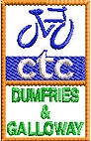

CTC DUMFRIES AND GALLOWAY
AGM

CHAIRMAN'S REPORT

Firstly may I apologise for the lack of correspondence from myself or the committee over the past two years, this has been due to a review by Cycling UK of their General Data Protection Regulation (GDPR) which in effect disabled our Secretary's access to the data base containing your email addresses. However this has now been resolved, hence you are receiving my report.

There has not been a full committee meeting in the last year but several Sub-committee meetings related to the Kirkpatrick Macmillan Rally and the Tour of the Machars Sportive which we held in conjunction with the Rotary Club of Newton Stewart. However the committee did provide a full program of both Sunday and Mid-week rides heading out from either Glenluce or the Newton Stewart area. While regular Mid-week rides were scheduled for those in the Dumfries area.

For a retrospective view of the year I have listed some of the events that were worthy of special mention.

Once again the year started with a collaboration with Cycling Dumfries resulting in a number of joint rides over the winter months, and included rides to celebrate Halloween, St Andrews Day, New Years Day, Robbie Burns and St Valentines Day.

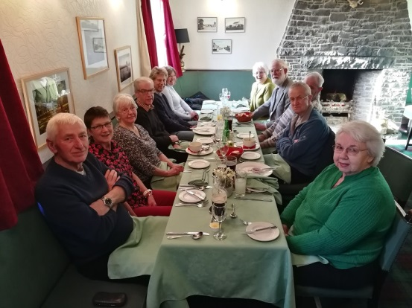
27th January Our first Member Group event was our Festive Lunch held at the Laurie Arms, Haugh of Urr.
Sadly only 12 of us were able to attend but an excellent day and lunch enjoyed by all.

27th March The first of three visits this year to our region by Cycle Ayrshire. Several local riders joined them for a joint ride around the North and Mid Rhinns of Galloway

6th April The Hunter Campbell Fat Boys Cycling Club came over from N. Ireland for a tour of the Machars with a lunch stop in Wigtown and an overnight stay at the Northwest Castle in Stranraer.
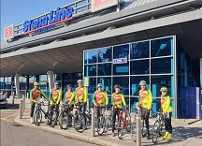
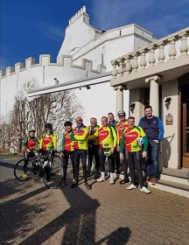

16th May Saw the launch of a promotional video featuring the SW300 Cycle Route, devised by Stephen (Nipper) Varney, the event being hosted by Chris Walker at the Selkirk Arms, Kirkcudbright.

24th - 27th May Was the weekend of the Kirkpatrick Macmillan Rally marking the 179th year since he invented the bicycle
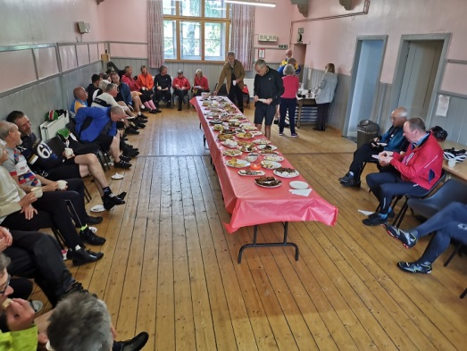
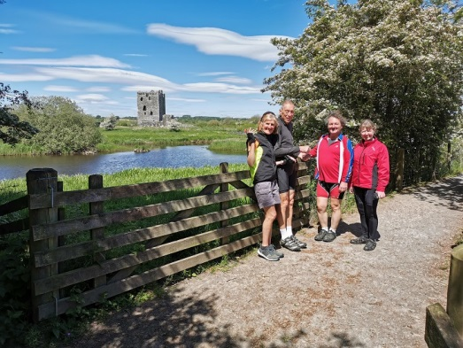
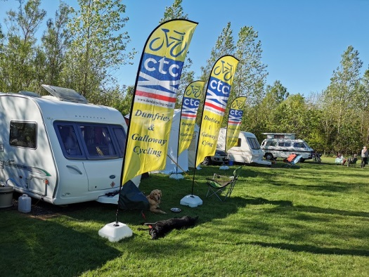

The KMR 179 was very well attended - some of the participants suggested that we should hold one in 2020 as it will be the 180th anniversary, and since the KMR is now the only rally held in Scotland (since the demise of the Grampian Rally) that we should consider holding it annually - which we are currently planning to do.

17th -19th May A few of us had a few days away for a Tour de Eden Valley in Cumbria.

16th June Tour of the Machars Sportive a joint venture between ourselves and the Rotary Club of Newton Stewart attracted over 100 participants
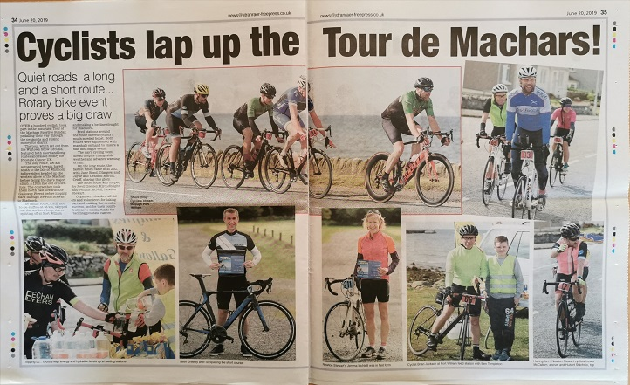

4th August Cycle Ayrshire joint ride around the Machars
Sadly with only about 20 mile covered two of the group took a tumble which resulted in an ambulance being called and the ride abandoned.
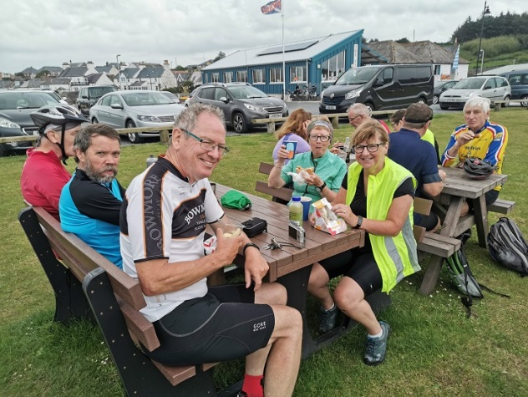
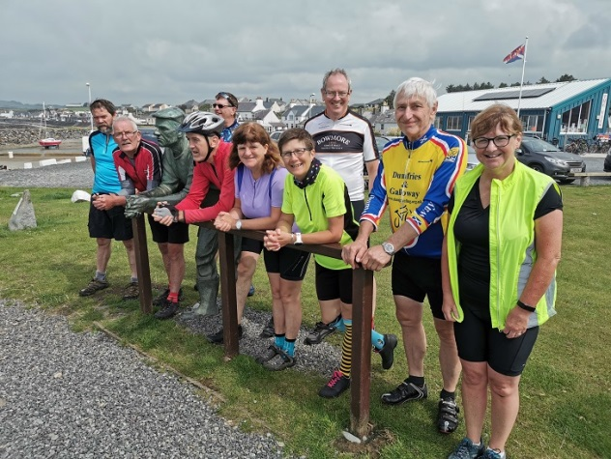

8th August A visitation by Integrity Cycling Club from N. Ireland, several local riders joined in the fun by riding down to the Mull of Galloway.

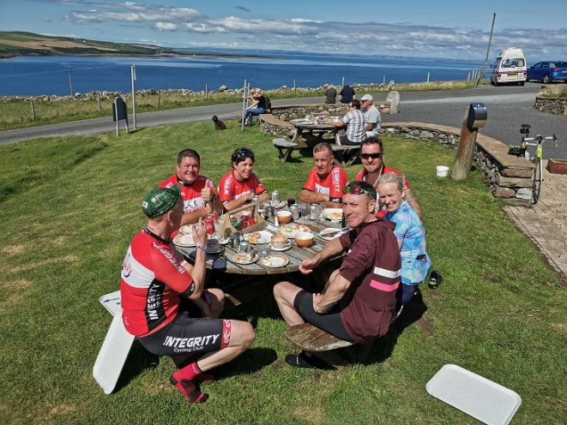
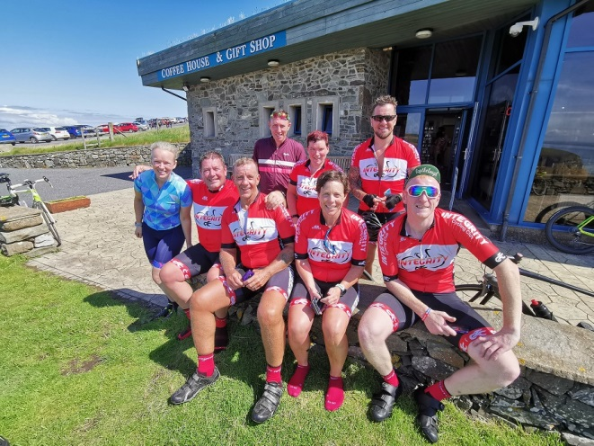

7th September Tour of Britain: to celebrate the arrival of the tour into Kirkcudbright. Chris Walker aided by Castle Douglas Cycles and Galloway Cycling Holidays laid on three rides varying from 15 to 65 miles followed by a BBQ at the Selkirk Arms .

22nd September Cycle Ayrshire returned once more in an attempt to complete their tour of the Machars - thankfully all went well apart from the weather which was rather damp.
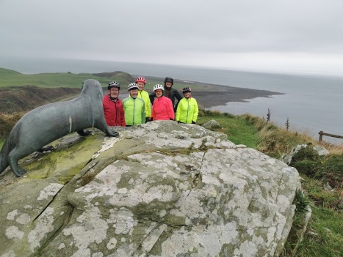
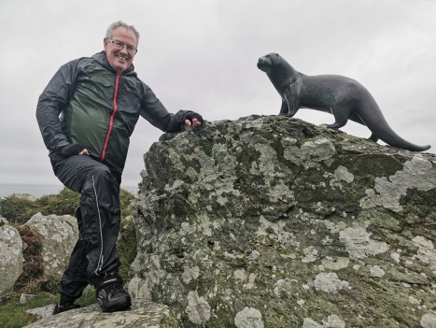
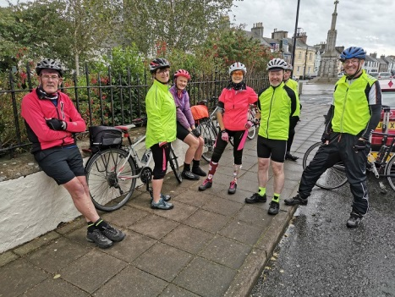

Finally can I thank everyone who contributed to making 2019 such a memorable year.

Kind regards, Robert Rostock.

CTC Dumfries and Galloway
Members’ Group

Ted Norfolk Treasurer
Cliff Cottage, Monreith, Newton Stewart. DG8 9LJ
01988 700432

Treasurers Report 1/10/2019

Balance at 1/10/2017 £2154.41 Balance at 1/10/2018 £2015.60

INCOME 2017/2018 INCOME 2018/2019

CTC Subs £200.00 CTC Subs £200.00
SI Entries £88.45 KM Rally £50.00

Totals: £288.45 Totals: £250.00

EXPENDITURE EXPENDITURE

AGM Room Rent £30.00 AGM Room Rental £30.00
Committee Meeting Food £65.10 Visit Scotland Website Fees £60.00
Committee Meeting Food £58.80
Notice Boards and Pens £112.07
SI Cancellation Fees £143.86
CTC Postage £17.43
Totals: £427.26

New Balance at year end £2015.60 New Balance at year end £2175.60

Represented by Represented by

£2015.60 in current account Clydesdale Bank £2175.60 in current account Clydesdale Bank

Prepared by Treasurer Ted Norfolk

EXAMINERS CERTIFICATE
I have examined the Books, Vouchers, Receipts and other items as presented to me and have received satisfactory answers to any questions I have raised.
I am satisfied that the above Income and Expenditure Account gives an accurate financial state of affairs of the CTC Dumfries and Galloway Group.

Date --------------------------------- ----------------------------------------------------------------------------Hon. Examiner.

Cycling UK Dumfries and Galloway Members Group

Following our AGM, Cycling UK Dumfries and Galloway Members Group are planning to invest some of our funds on increasing the promotion of cycling in our area. This will take the form of upgrading our website to make it more used friendly and speaking to Cycling UK to get them to add our area to their current promotions as we feel it is being neglected at present.
We will aim to try to capture more of the holiday makers who come to our region to cycle but are probably unaware of what is going on and who to contact in terms of organised rides, events and ride groups.
We have arranged a committee meeting in January to progress this plan and ideas such as an area cycle route map and publicity brochures will be considered.
The continuation of the £200 annual subscription will be vital to our future plans.

Ted Norfolk (Treasurer)

