**CTC Cornwall (Part of Cycling UK)**

**EASTER FAMILY CYCLE RIDES AND BBQ**

**SUNDAY 14th APRIL, 2019 Meet 11.30 am Siblyback Car Park**

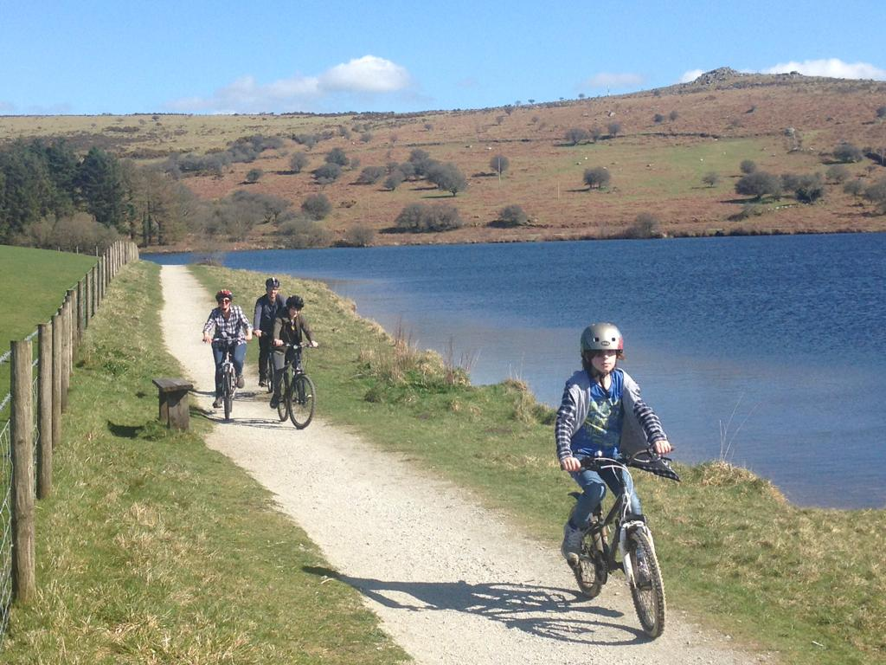

Confidence building bicycle rides including one for parents with smaller children around Siblyback Lake (three miles) followed by BBQ on shore of Siblyback Lake with kind permission of South West Lakes Trust.

**Meet 11.30 am Siblyback Car Park** (parking charge £2). Everyone welcome. Just need bicycle, waterproof - and cycle helmet.

BBQ provided by Rockhopper Cafe at 1 pm on shore of Siblyback Lake near to car park (under cover if weather poor) - no formal charge but suggested donation of £3 per person (burger or sausage in bun; choc bar or fruit; and drink).

*(NB Liskeard Velo to meet same day 10 am at The Parade, Liskeard, PL14 6AW. Ride to Siblyback Lake for BBQ at 1 pm with cafe stop Jamaica Inn.)*

No need to book. Further information from [info@ctccornwall.org.uk](mailto:info@ctccornwall.org.uk) (Ann 07720 783 401)

**Please note, may be SW Lakes photographer present. Please let organiser know if you do NOT want your child’s photograph used in SW Lakes publicity material.**

Hope to see you there!