Wednesday 22nd May 2019 Car assisted from Ballinluig.
Meet at the car park in Ballinluig (about 70 miles from middle of Edinburgh and Google says 1hr 40 mins), just off the A9 from the turn off for the A827. Turn right when off the A9 and proceed to Ballinluig (about 500 m) there is a petrol station and café – The Motor Grill here and a lorry park and there is space for cars too. So a variety of options for parking. Toilet available in the Motor Grill.
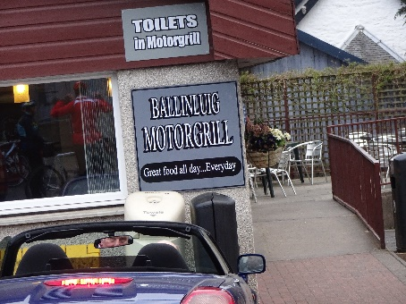
We gather at 0950 for a 1000am depart. We cycle back over the A9 along the A827, cross the Tummel River and ride on the north side of the river Tay and take the first right in Logierait, up a vicious little hill (change down before you hit it!) onto a quiet undulating road which takes us to Pitlochry. Then it is the old A9 to Blair Atholl and on to The House of Bruar for a mid-morning stop. Café and Toilets here. 28 kilometres
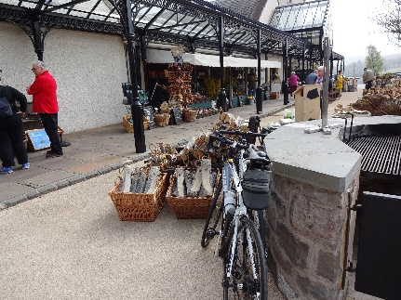
Back onto the old A9 which we follow until Dalnacardoch where we turn left and cross the River Garry and the railway climbing and then descending to Dalchalloch and on to Kinloch Rannoch for a café stop and a late lunch. 30 kilometres
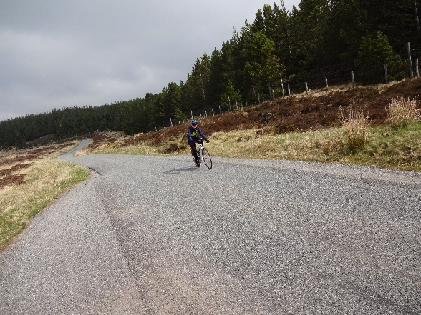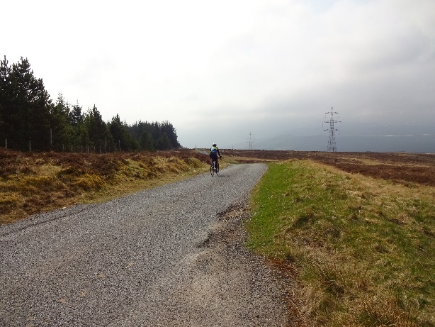
From there we climb the Schiehallion road as far as the B846 which we follow to Weem, staying north of the River Tay all the way back to Ballinluig 42 kilometres
Total 100 kilometres and about 1300 m of climb
There are opportunities to shorten the ride along the way e.g. miss out Dalnacardoch and go directly to Dalchalloch, and/or return to Pitlochry from the road above Dalchalloch or Kinloch Rannoch.
See mapometer route here.

