C&NW CTC Hill Climb & Freewheel 2026 -info sheet
Freewheel course – due to 20mph restriction it will now be west of Llysfasi NOT in Graigfechan

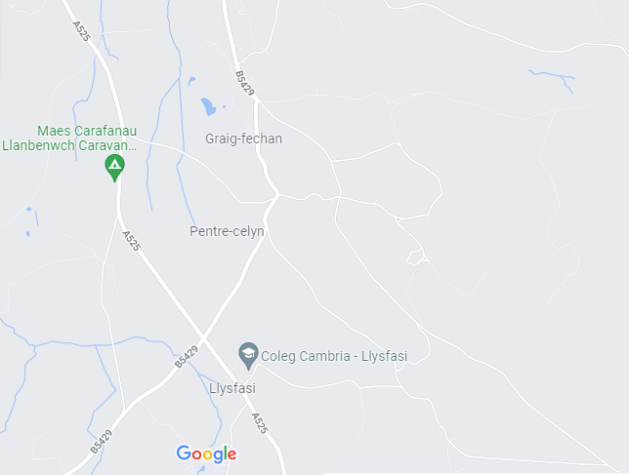
Key
Route from book in to hill climb
Route from hill climb to freewheel. A525)
Route to Llanbenwch from freewheeling

Competition courses
Booking in at Llanbenwch
Sign on the A525; there is a gravel drive leading to the café.
Book in from about 10.40am. We will be leaving Llanbenwch to ride to the start of the hill climb at 11.15, with first rider starting at 11.30 approx.
Parking
Parking available at Llanbenwch. Café will be open before the events if people want cuppa etc. (Most people did this last year 😊) After the events Llanbenwch will be the venue for lunch & presentations for the results & presentations.
If you are parking for the duration of the events please don’t park right up by the café; leave the spaces for those who are less mobile or who may only be there for a short time. Thanks.
Freewheel course
Book in at bus stops
Hill Climb course
Please contact organiser Lowri Evans 'Lowri Evans' secretary@ctcchesterandnwales.org.uk to confirm if you are either able to volunteer or will be riding one or both of the events. Numbers will be given to the café to reserve space for lunch.
Entry forms can be sent by email prior to the event or handed in on the day. Fees £1 per event (cash only).

There are NO facilities at the start – only facilities will be at Llanbenwch before & after the event.
People are invited to enter one or both of the competitions.
These ‘fun’ competitions which allow members of Cycling UK to enjoy a social day out. After the events everyone will return to the cafe at Llanbenwch campsite where results will be calculated and winners announced. Touring Caravans | Camping Site | Denbighshire North Wales (llanbenwch.co.uk) There is a new indoor café & additional seating under cover. Permission has been given for people to park here & use of toilet facilities prior to the event; Please park at the further ends of the car park. (Many people turn up early enough for a cuppa at the café prior to the events- café opening (9am – 4pm)
The entrance to Llanbenwch and route to the café is gravel so please take care when entering /leaving the venue.
Entry fees: £1 per event (which can be paid on the day)
Covid-19 Rules
Please do not attend if you have symptoms of Covid-19 or similar & have any reason to believe that you could be infectious to others.
GDPR & photographs Cycling UK notice:
Please be aware that there may be filming and photography during this event. Please let one of the organisers know if you do not consent for any images taken to be used in our communications channels, including our social media, website, magazine or other publications. Many thanks.
Organiser contact details:
Lowri Evans lowri.1evans@btinternet.com 01824 705709
Mobile number (ONLY to be used on the day) 07593541112

