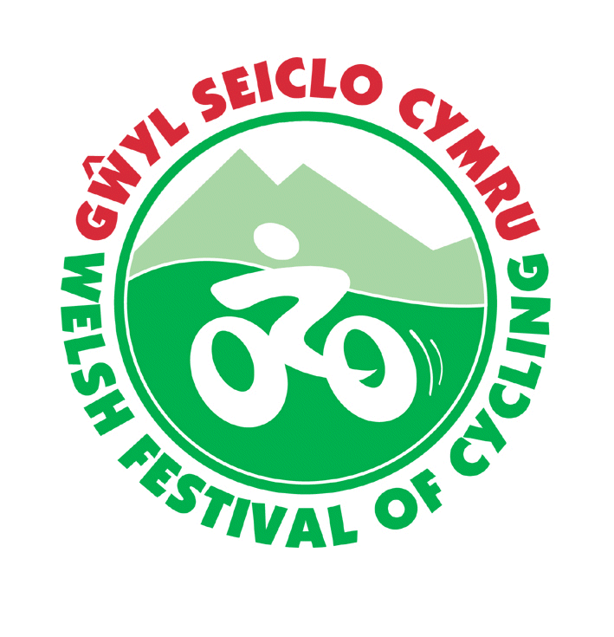
Welsh Festival of Cycling
CTC Cymru
Gŵyl Seiclo Cymru
Booking Form
Thursday 23rd to Tuesday 28th July 2026
Clwb Rygbi Rhuthun Ruthin Rugby Club

Please read the instructions on the last page then complete this form in block capitals and send it to:
Welsh Festival of Cycling 2026, 86 Bro Dêg, Ruthin, Denbighshire LL15 1XY
Please register the following persons for the Welsh Festival:
 | Surname | First name | Title | Cycling UK membership number | Child/  Student
1
2
3
4
5
6

Registration Booking:- | Number | Price | Cost
Adult registration |  | £16
Children under 16 or f/t students under 21 |  | £3
TOTAL REGISTRATION FEES (non-refundable)

Your name and the address to which all correspondence should be sent:
Name:....................................................................................................
Address:...................................................................................................................................................................................................................................................................................................................................................................................................................................................................................
Phone: day..........................................Evening...................................Mob..........................

Email.........................................................................................................................................

Emergency Contact: Name..................................... Contact number......................
Vehicle Registration number if driving to the event …………………

CAMPING
Number of pitches required. Tents.................... Caravan/Motor home..............................
The campsite package is for Thursday through to Monday night (site to be cleared by 10am Tuesday)
If you are booking on the basis of single nights, please circle which nights
Thursday Friday Saturday Sunday Monday

 | Number | Price per  unit | Cost
Tents
Number of pitches (includes one adult camping per pitch) |  | £35.00
Additional adults on the same pitch (per adult) |  | £20.00
Registered children – camp free with accompanying adult
Camping pitch- single nights includes one adult |  | £8.00
- Single night additional adult |  | £5.00
Caravans/Motor Homes
Number of pitches (includes one adult camping per pitch) |  | £40.00
Additional adults on the same pitch (per adult) |  | £25.00
Registered children – camp free with accompanying adult
Caravan/Motor home - single nights includes one adult |  | £9.00
- Single night additional adult |  | £8.00
Total camping
Please note there are no electric hook ups & batteries mustn’t be left unattended whilst charging.

Summary of costs | Cost
Registration fees
Camping fees
Final total

I enclose a cheque for £_________ made payable to CTC Cymru
(please do not send cash – for other methods of payment please see Booking Instructions on next sheet)
Signature...........................................................Name...............................Date....................
Please send the completed form to:
Welsh Festival of Cycling 2026, 86 Bro Dêg, Ruthin, Denbighshire LL15 1XY

Please accept cashing of your cheque as confirmation of booking

Booking instructions
Please send in a booking form if you are attending the Welsh Festival in 2026 – there is a limited amount of camping space so organisers need to know how many people are coming.
Camping
Work will be taking place in the late spring/summer on a new active travel route from the rugby club through the park (Cae Ddol). This may affect access to the camping area.
The site is protected so care must be taken not to damage the site. It is not suitable for very large campervans/caravans, if there is extremely wet weather vehicles may need to be moved from the grass area.

Postal
Please complete the form and post it with payment to:
Welsh Festival of Cycling 2026, 86 Bro Dêg, Ruthin, Denbighshire LL15 1XY
Online
If you want to book online and need to make an online payment, please email Lowri Evans secretary@ctcchesterandnwales.org.uk for details of the CTC Cymru account & let us know the amount you will be paying & the account name so that we can match payments to attendees (if you are able to please send a scan of the completed form as an attachment to the email). Please include your name & Welsh Festival Booking in the email subject – thank you.
We can supply the booking form as a Word document on request if this makes it easier to complete & attach to an email.

Route sheets
Route sheets will be available from late afternoon on Thursday 23rd July at the Rugby Club.
It may be possible to send out some GPX route files a few days before the Festival – please email Lowri Evans secretary@ctcchesterandnwales.org.uk for the files. Please include your name & Welsh Festival Routes in the email subject – thank you

Audax Events
There will be a choice of 2 Audax events from the Festival on the Sunday – please enter these as usual via the Audax website

Signing in form
All attendees will need to complete at registration form which has details of mobile numbers emergency contacts and a disclaimer. This can either be printed off at home then handed in when registering at the Festival or filled in on arrival – young riders will need to have the parental consent section of the form completed. No unaccompanied minors.

Local riders who are just coming for the day will need to complete a signing in form and can pay cash on the day. Please arrive in good time.
Contact numbers:
Lowri Evans 01824 705709
Gwenda Owen 07875 333234

