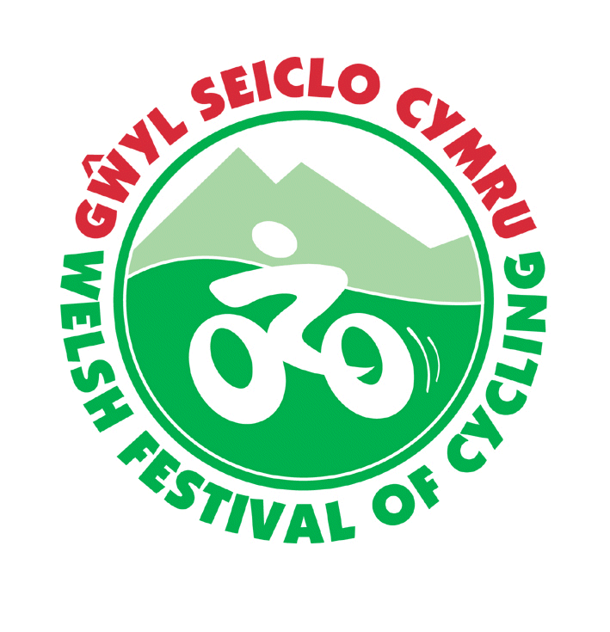
Gŵyl Seiclo Cymru
Welsh Festival of Cycling
Clwb Rygbi Rhuthun 25/7/2024 – 30/7/2024 Ruthin Rugby Club
Croeso Welcome
CTC Cymru is pleased to announce that the 2024 Welsh Festival of Cycling is returning to Ruthin.
The Festival provides an opportunity for cyclists of all descriptions to experience the beauty of Denbighshire and beyond with rides which have been geared to a range of abilities and interests.
Ruthin lies in the Vale of Clwyd about 20 miles inland from the North Wales coast. The location gives scope for gentle rides in the valley or hillier rides taking in the Clwydian Range, Denbigh Moors, or the Berwyns.
The Festival is based at Ruthin Rugby Club which has camping available for solo & large tents and also space for caravans and motor homes.
What’s On
For 2024 the Festival will run over 4 full days, with the first rides starting on the Friday morning (registration from 4pm Thursday afternoon). Five nights camping is available at the Rugby Club from Thursday 25th July until the morning of Tuesday 30th.
People may also attend for just one day
Route sheets & GPX
Participants can pick up their routes sheets when they register their arrival at the event. There will be a range of routes available, from short family rides to longer more arduous routes. There may be ride leaders for a few of the rides, however most rides will be self -led. The rides will give an opportunity to explore the lovely surrounding hills and will mainly be on quiet lanes.
It may be possible to send out some GPX route files a few days before the Festival – please email Lowri Evans secretary@ctcchesterandnwales.org.uk for the files. Please include your name & Welsh Festival Routes in the email subject – thank you

Evening Meals
The rugby club may be able to provide evening meals at the weekend. Details – cost & menu choices will be available at the Festival. Meals will need to be booked at least a day in advance so that the caterer has numbers to work form.



Registration and Accommodation
To book a place costs £15 for an adult and £2 for a child under the age of 16 or a full time student under the age of 21. This booking fee is towards the costs of organising and publicising the event, and providing routesheets (which you can keep should you wish to return to this excellent cycling area). This fee is non-refundable.
If you wish to camp the site will be open from Thursday afternoon and the prices are as follows:
Tents
£30 per pitch for the tent and the first adult for the 5 nights. If there is more than one adult it will cost a further £16 per person. Additional children & students who paid the lower registration fee are free.
Those staying less than 5 nights will be charged £7 per person per night for the first person with additional people charged at £4 per night.
Caravans & motor homes
£35 inclusive for the pitch for the first adult for the 5 nights. If there is more than one adult it will cost a further £20 per person. Additional children & students who paid the lower registration fee are free.
Those staying less than 5 nights will be charged £8 per person per night for the first person with additional people charged at £5 per night.

There are no electric hook-ups.
Other accommodation
Information is available from the Welcome to Ruthin website www.ruthin.com/stay.html
How to book
Please use the festival booking form and book in advance. This will be available on line at:
https://www.cyclinguk.org/event/welsh-festival-cycling-0
Or from Emrys Jones 01952 257522 demrys2jones@hotmail.co.uk
Or from Lowri Evans 01824 705709 secretary@ctcchesterandnwales.org.uk
Or Gwenda Owen 07875 333234 gwenda.owen@cyclinguk.org

Completed forms should be sent to:
Welsh Festival of Cycling 2024, 8 St Chad’s Close, Wellington, Telford, Shropshire, TF1 3EW

