In August 1914, CTC approached the War Office in order to offer the services of a large number of cyclists to the war effort shortly after hostilities started. While appreciated, the offer was initially declined. Despite this, CTC put out an appeal for members to come forward who were willing to offer their services to the Army Council should it be required in the future. Later the same year, the Commandant of the Sixth (Reserve Cyclist) Battalion of the Royal Sussex Regiment approached the Club with a request for recruits. Two cycling battalions were formed and were largely made up of CTC members…

CTC, Cyclists and War: 1915

[FEBRUARY, 1915]

The C.T.C. Cyclist Companies
“A Third Battalion – to be called the Sixth Second Reserve (Cyclist) Battalion of the Royal Sussex Regiment – is now being formed, and it has been decided to make this a special C.T.C. and N.C.U. (National Cyclists’ Union) Battalion. Prospective recruits should lose no time in presenting themselves to Colonel Finlayson, Finsbury Pavement House, London, E.C., or to the Commanding Officer, 18 Montpelier Place, Brighton. The minimum height is 5ft 4in, the minimum chest measurement 34in, and good eyesight without glasses is essential.”

[MARCH, 1915]

The C.T.C. and the War
“Members will read with pride and satisfaction the announcement that the full number of men required for the two Reserve (Cyclist) Battalions of the Sixth Royal Sussex Regiment were obtained some time ago, and that the special C.T.C. Companies are doing themselves and the Club full credit in the arduous training they are undergoing before being sent to the front.
“It is quite on the cards that the formation of yet another battalion will be sanctioned, in which case the Club will again have the privilege of assisting in the recruiting, and members will be informed as early as possible through the Gazette.”
A female member, Miss Macfarlane, is listed on the third Roll of Honour, engaged in the Red Cross in Brittany. Under the headline ‘Off To The Front’ there is also an advert for French and German phrase books, “stocked at the C.T.C.”
The Gazette also notes: “Many C.T.C.-ites are now actually in the fighting line. Some, alas! Like that very gallant Major Yate – who was among the first to be awarded the V.C. – are numbered with the slain. Some are prisoners of war. Others have been wounded. But all who remain on the effective list, we make no doubt, are exhibiting the courage and fortitude which confers distinction on themselves…”

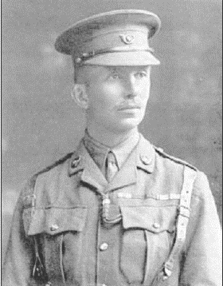
Major Charles Allix Lavington Yate
led his 19 surviving men in a charge at the Germans at Le Cateau, France, in the first weeks of the war. After being captured and spending one month in a POW camp in Germany, he managed to escape – but is believed to have cut his throat to avoid recapture after being apprehended by local factory workers. He was posthumously awarded the Victoria Cross before the end of 1914.

Annual General Meeting
The 1915 AGM was held at Stuckey’s Restaurant, Wine Street, Bristol on Friday 12 March.
At the 1915 meeting, Colonel Savile “made reference to the praiseworthy efforts of the Council to raise additional troops for the nation in the form of cyclist battalions.”
The attendees applauded when the secretary said the two battalions already in existence were formed largely of CTC members. Until they went on active service, however, it was understood that a third battalion could not be sanctioned.

[APRIL, 1915]

The Roll of Honour lists two CTC members killed in action this month.
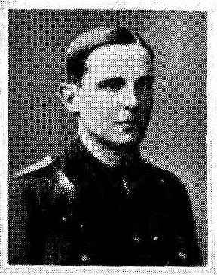
Lieutenant Rowland George Prichard
1st Battalion, The Suffolk Regiment, was only 19 when he died while gallantly leading his men in an attack on German trenches at St Julien, near Ypres, on 27 April. He had been accepted at Brasenose College, Oxford, but obtained a commission as a 2nd Lieutenant on 15 August 1914 – 11 days after Britain went to war. He was buried near St Julien, in the rear of the trenches along the Zonnebeke-Ypres Road.

Private Samuel William Bowles
Of Forest Gate, in the London borough of Newham, died on 1 April. A draughtsman who was born in 1893 in South Shields, he fought with the 7th (City of London) Battalion, London Regiment. He is remembered on the Le Touret Memorial in the Pas de Calais, France.

[MAY, 1915]

More CTC men wanted for the Front
The Gazette reports: “As foreshadowed in the annual report of the Council, presented at the last Annual General Meeting, more military cyclists are urgently needed for Foreign Service. We are able to announce that the War Office has sanctioned the formation of a third battalion of cyclists for the 2/6th Royal Sussex Regiment, which, as our readers know, is the regiment the C.T.C. has been privileged to co-operate with and in the first and second battalions of which so many of our members are serving.”
The article talks about preliminary training at Hove and says the men would be transferred to Suffolk and ultimately join the British Expeditionary Force.

How to Spend War-Time Holidays
W. A. Russell’s article says members who are too old for active service but would like to get involved should join their local volunteer regiment. He goes on to talk about the history of the volunteer regiment and how Germany already has “her middle-aged men mobilised”.
At the end of May another CTC member loses his life, again aged only 19.
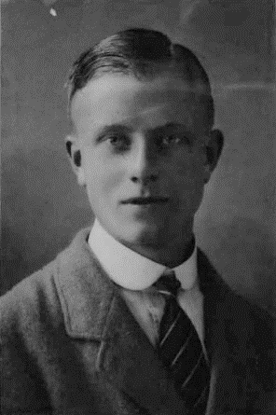
Flight Lieutenant Herbert Graham Wanklyn was an early Royal Naval Air Reserve fatality. According to Airfields and Airmen of the Channel Coast, by Mike O’Connor, the London-born pilot was posted missing on 31 May, little more than two weeks after arriving in Dunkirk for action. He took off at 03.30am for a patrol to Ostend in Maurice Farman Pusher Seaplane No 114. “Whether he was shot down by ground defences or suffered an engine failure is unknown, but his body was found in the sea nearly three weeks later on 17 June.” He was buried in Calais Southern Cemetery.

[JULY, 1915]

The Gazette’s CTC Roll of Honour for July has Private H Abrahams listed as “killed in action”.

[OCTOBER, 1915]

An excellent example
“Sir, - As I shall be on active service within the next few days for an indefinite period, I enclose my next year’s subs. to the Club in order that there may not be a mistake at Christmas should I happen to be out of the country. I do not wish any mischance to break my connection with the C.T.C for, besides being of the greatest assistance on my cycle tours in the matter of accommodation, customs’ tickets, maps, rebates, etc., it has given me some of the best friends I have, and the happiest days I can remember have been spent wandering in various parts of Europe under the Club’s auspices…” Letter from a member signed H.R.C.C.

[NOVEMBER, 1915]

Royal Sussex Cyclists wanted
“Cyclists are required at once for the Foreign Service to complete the 6th (Reserve Cyclist) Battalion of the Royal Sussex Regiment. The headquarters are at Brighton, and training will take place there and at Windsor under ideal conditions.”

[DECEMBER, 1915]

The CTC and the War
Despite CTC’s efforts to encourage members to join the war effort, A.W. Rumney, Councillor for Surrey, writes a letter insisting: “It seems to me that we, as a club, are not doing our bit at this critical time in our national affairs… I would suggest at this time of subscription renewal that those who can afford it should add their shilling, half-crown, sovereign or note, which might be devoted to a Y.M.C.A. hut, bearing the name of the Club, and I beg leave to open the ball with £25.” Mr Rumney suggests a half-crown donation from 8,000 members could pay for one hut abroad and another in Britain.
Another member writes: “Dear Sir, - As I expect that my regiment – East Lancs. RE.A.M.C.T. – will shortly go abroad on active service, I send my subscription to the C.T.C now. I do not wish to break my connection with the Club whilst I am away.” He goes on to talk about the love of the old club and the fraternity of cyclists.

The Gazette published six Rolls of Honour listing serving CTC members during 1915, recording seven deaths. Little did anyone realise the ‘war to end all wars’ was to last another three, long years…

