


Leader

CTC Education
62-68 Thirlwell Road, Sheffield, S8 9TF

Tel: 0844 736 8463
Email: training@ctc.org.uk
www.ctc.org.uk/training
Logbook
Mountain Bike
Leader & Instructor Awards

National
Mountain Bike Leader Awards

Leader Logbook

© Copyright CTC 1996-2013

All rights reserved. No part of this publication may be reproduced in any form or by any means without permission from the publishers.

To ensure that maintenance of appropriate and high standards of the Awards, CTC reserves the right to alter any course specification or detail without notice.

For technical queries about the Awards, please contact:

CTC Education Office
62-74 Thirlwell Road
Sheffield
S8 9TF

0844 736 8463
training@ctc.org.uk
www.ctc.org.uk/training

Logbook

As a Mountain Bike Leader you will be mountain biking both for yourself and with groups. There are three reasons you should document your experience as you undertake these rides:

- You have to complete most of this work as part of the preparation for the ride anyway. For example details of the route, times and group members need to be left with a base contact. It is simply a case of collecting that information back and putting it into a file.

- When you go on to a course assessment or training at a higher level, you will need to provide a logbook for the rides that you have undertaken. Including the content of a logbook of personal and leading experience as a Mountain Bike Leader adds substantial evidence to your portfolio.

- Should your experience ever be called into question, you have documentary evidence to support you.

Logbook Content

Your logbook should be split into two areas:

- Personal experience gained through mountain bike rides on your own, and/or with friends or colleagues.
- Leading experience gained through being formally in charge of a group when mountain biking. You may or may not be paid for this work (it doesn’t matter in terms of your logbook), but you will have responsibility for the preparation, implementation and follow up of these rides.

Notes on map use and reproduction:

Under Ordnance Survey license guidelines, you can reproduce single copies of maps for personal use up to A4 size. This applies whether you are printing from an electronic map, or photocopying a paper map.

Your logbook should not require you to operate beyond these restrictions. For clarification, please consult Ordnance Survey directly.

Blank copies of sample sheets are provided hereon. The outline for each ride type should comprise the following:

Logbook Content
Item | Content for Personal Rides | Content for Leading Rides
Master Sheet | Ride reference number  Ride date  Any incidents and notes including:  - unusual weather conditions  - accidents (real or potential)  - mechanical problems | As for Personal Rides
Route Outline | Using one of the following. preferably one of the first two:  - outline of the route on a photocopy of a topographical map (it is legal to produce an up to A4 copy of OS maps for personal use). This map should identify rights of access when based in England and Wales. See an example on page 6.  - print out of an electronic topographical map, with the route (and direction) highlighted. This map should identify rights of access when based in England and Wales. See an example on page 6.  - tracing of the route, identified with region of the UK, scale and grid line crosshair so it can be overlaid on an OS map  - route card
Session Details | Length of the ride (in time)  Personal aims, such as skill development; pre-ride check. | Start time  Expected and actual finish time  Outline of the aim and content of the session, for example skills development; group social development
Participant Details | Not applicable | Group ability and experience. This shows evidence of different groups, abilities and backgrounds.  Data protection act:  Your own ride preparation will require details of participants addresses and emergency contact details. For the purposes of your logbook, please provide participant names or ages, experience and gender mix only.

Pages 5 and 7 can be reproduced for the use of CTC Mountain Bike Leaders documenting their riding experience only.

Logbook Master Sheet
Ride Type: (Please tick) |  | Leading | Personal
Ride No. | Ride Date | Weather | Incidents and Notes | Verified
1
2
3
4
5
6
7
8
9
10
11
12

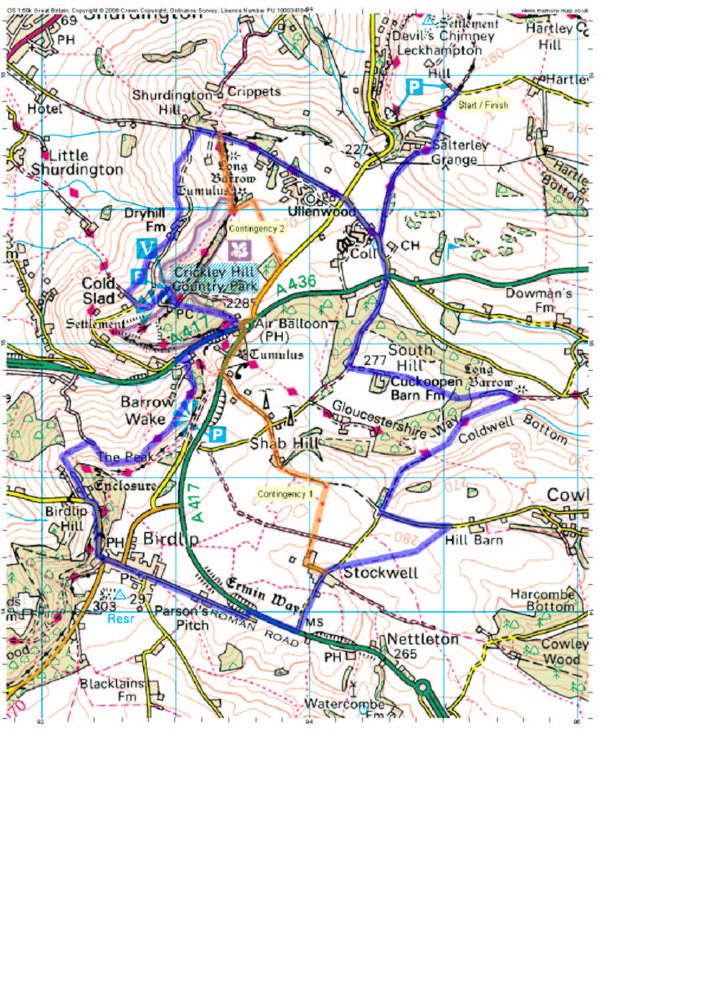
Map example: Ride: L6
Map reproduced under Ordnance Survey licence 100045061

Route: Leckhampton – Birdlip circuit
Area grid letters: SO
Date: 29/02/04
Group: Y9, Heretown School – see attached participant list
Loop direction: Clockwise

Start time: 12.30pm
Expected finish: 4.30pm
Emergency Action Time: 5pm – see attached procedure

Leader Contact Tel: 07123 456789

Participant Details
This participant detail sheet is provided for your use. In order to fulfil the requirements of the data protection act, please only provide participant names (or initials) and experience for your leader logbook, although full details will be required when leaving with your base contact.

Participant Details
Ride No.: |  | Date:
Participant | Experience: | Medical Details: | Emerg. Tel.

