Annual Report 2014 -2015  Cycle Basingstoke  Affiliated to CTC | 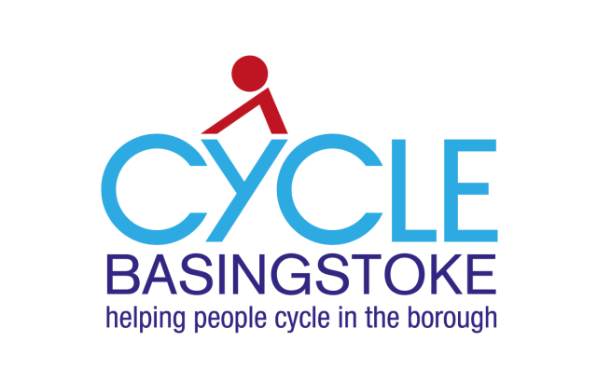 | 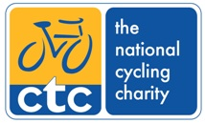

Introduction
Heather extended her cycle campaigning role as R2R rep by initiating a local cycle campaign in order to gain a wider support base, especially non CTC members and local business. The first general campaign meeting was during Green week September 2014 and attracted 20 people. Since then there have been monthly meetings to devise strategies and action plans.

Cycle Basingstoke has replied to many planning applications and consultations as well as having a lot of meetings with the borough council and the local MP see below.

Consultations have included:

- National consultation – Cycle Delivery Plan (October 2014)
- Local Plan (emails, spoke at meeting 11th December 2014)
- COG on transport (commissioning outcome group for Basingstoke and Deane)
- HCC cycle strategy
- Basingstoke cycle map and strategy (meetings, reports and emails)
- Local Transport Summit
- Basingstoke Transport conference
- Cycle infrastructure proposals for Rooksdown and Winklebury
- Cycle infrastructure proposals to connect Popley and Chineham centre via Wade road
- Traffic management improvement plans (roundabouts) (exhibitions and written replies)

Planning applications have included

- Tescos – supermarket + houses – withdrawn January 2015
- Rooksdown golf course
- Brighton Hill roundabout
- A340 near hospital
- Various minor applications
- Basing View
- Pyotts Hill
- Critical Care Unit at North Waltham

Networking and liaison:

- Maria Miller MP, (4 meetings) esp. site visit for station access, Victory and Eastrop roundabouts
- Cllr Paul Harvey MP candidate (roundabouts)
- Basingstoke Transition Network (BTN) - monthly meetings
- Colin Carre and Susan Keywood CTC cycle development officers for Hampshire(My Journey)
- Breeze
- Oakley Pedlars
- North Hampshire Road club
- Sustainable Basingstoke
- North Waltham Cycle Chain Campaign
- Whitchurch Cycle Campaign
- CTC: North Hampshire committee, Head office, Hampshire Cycling, R2R web group
- Local bike shop owners
- Local councillors and local council officers
- Ride London, Heather helped with Dr Bike – met organiser for Watford Bike Hub
- Cycle Campaign meeting (CTC–Cyclenation Annual Conference Nov 2014 hosted by LCC and sponsored by Lambeth Council, London)
- Basingstoke Voluntary Action (an organisation supporting local charities and community groups)
- Sustrans
- Northamptonshire county council (cycle maps)
- John Franklin (author of Cyclecraft and initiator of Cheltenham cycle map)
- Fleet Cycling and Fleet cycle campaigners (station parking and Fleet cycle map)

Achievements

- The cycle campaign group has now chosen a name – Cycle Basingstoke. It has a constitution, a website, a bank account, a logo (designed by Bob Bending) and publicity materials (banners, posters, business cards, flyers).
- Cycle Basingstoke and CTC are providing cycle rides for Green Week and an advice centre in Festival place.
- In May we became a member of BVA.
- In August we became an affiliate group of CTC. The first AGM is on 23rd September
- As well continuing support from local Labour councillors we now have support from conservative councillors Mark Ruffell (cabinet member for planning and infrastructure) and Cathy Ossleton (cabinet member for partnerships incl. transport policy and planning) - essential if we are to get a good cycle map and cycle strategy.
- More cycle racks have been added to the cycle parks outside Marks and Spencers and the library in Basingstoke. None provided in Top of Town. There have been cycle racks in obscure locations off New Road. We have not obtained permission for cycling in Top of Town, although this is supported by Sustrans who were commissioned to provide the cycle map and strategy.
- Sustrans conducted the largest ever cycle map consultation of its kind. Over 2,000 responses. Key issues were places to avoid, busy junctions, barriers, lack of signage, lack of crossings.
- We have developed a good working relationship with borough officers

Membership and finance – see separate reports

National campaigns on infrastructure standards
CTC Right to Ride and Cycle Basingstoke have been affected by:
- Space for Cycling http://spaceforcycling.org/uk/ has been adopted by many cycle campaign groups in the lead up to the elections. CB has given out illustrated guides to local councillors and new members of CB. http://www.ctc.org.uk/sites/default/files/1404-space-for-cycling-guide-local-decision-makers.pdf. London Cycle campaign produced their own illustrated version
- http://s3.amazonaws.com/lcc_production_bucket/files/9134/original.pdf?1434446759
- Cyclenation (a federation of all the local cycle campaigns) has produced making space for cycling www.makingspaceforcycling.org.
- Sustrans has also published a document on this theme http://www.sustrans.org.uk/sites/default/files/file_content_type/sustrans_handbook_for_cycle-friendly_design_11_04_14.pdf
- The blue superhighways were trashed by the media until a campaigner demonstrated corporate approval from big business and blue chip companies in the city. This support is not surprising when you consider that many of their employees are high earners and cycle to work.
- City of London is consulting on its second London Cycle Design Standards which are a big advance on those advocated in LTNs used by local authorities. Welsh Active travel Act has also introduced higher design standards.
- Heather replied to the consultation on The Cycling Delivery Plan (October 2014)

Future plans

We will continue to lobby for better infrastructure, better cycle map and better cycle strategy
We will continue to liaise and network as widely as possible. In particular we wish to attract corporate sponsorship. It would be good to educate business in the benefits of cycling to business, it would provide good publicity and also help our funding.
We need to improve our organisation:
- find a project to promote cycling and consider a cycle hub to provide cycle maintenance training based at BCOT, the local technical college.
- promote Cycle Basingstoke and increase our membership
- Expand and improve our website
Get local cycle clubs to participate/become affiliate members

Thanks are due to:

Cycle Basingstoke members for their dedication and hard work
CTC North Hampshire for financial and practical support
CTC HQ financial and practical support and advice
Basingstoke and Deane Borough Council

