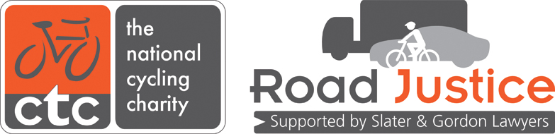
How to set up a working partnership with the police
Why do local campaigners need to engage with the police?
One element of the Road Justice campaign is for local campaigners to engage with the local police force in order to put pressure on them to first pledge to implement the recommendations in the report ‘Road Justice: the role of the police’ and then monitor their progress and assist them in implementing those recommendations.
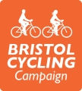
This is a best practice example of local campaigners’ engagement with the police from Bristol Cycling Campaign (BCyC).
BCyC is a cycling campaign group led by a small team of volunteers with several thousand supporters. They have set up a working partnership with Avon & Somerset Police (A&SP) to further the goals of the Road Justice campaign in their area.

How did Bristol Cycling Campaign engage with Avon & Somerset Police?
- Set up a Road Justice sub-group formed of three people, with assistance from CTC’s Road Justice campaign coordinator.

- Used Twitter to point out to the Police and Crime Commissioner (PCC) and Chief Constable that Avon & Somerset had not signed up to the Road Justice recommendations and directed them towards the map of police force pledges (www.roadjustice.org.uk/police-petition-map). This action secured a pledge from the PCC and, on the back of this pledge, BCyC were able to get a meeting with the Chief Constable to find out how the police would fulfil their pledge.

- Conducted research into the circumstances of incidents of pedal cycle collisions on a notoriously bad road in Bristol and the police’s response to these incidents. They discovered that in 25 cases of injury to cyclists caused by driving, there was: one prosecution for dangerous driving; one prosecution for driving without due care and attention; and one fixed penalty notice given out. The remaining 22 cases (88%) resulted in no further police action. The research was carried out via a Freedom of Information request to the police.

- Collated anecdotal evidence from BCyC members of cases that had been poorly handled by the police. Submitted these cases to the police to look into in greater detail to find out why they had been so badly handled.

- Collected Bristol-wide data on cycling and pedestrian collisions.
- BCyC and the Road Justice coordinator met with the Chief Constable and the head of the collisions investigations department to discuss the research and the Road Justice campaign’s recommendations (in the report ‘Road Justice: the role of the police’).

- Kept a good record of meeting minutes and circulated these after the meetings for input from others. This is valuable for keeping track of commitments made and which actions have been allocated and to whom.

- Informed the wider BCyC membership of progress via news articles on the BCyC website.

- Informed the Road Justice campaign coordinator of meeting outcomes and progress.
Why has this form of engagement been successful?
- Use of Twitter meant initial engagement was public and a response was swift
- Good quality research was a persuasive argument for action
- Case studies were impactful and hard to ignore
- BCyC approached the issues in a professional way which gave them credibility
- They established a working relationship with a senior police officer
Progress to date
- One of four cases presented to the police resulted in a careless driving charge when the police had originally decided to take no further action.
- BCyC are now recognised as stakeholders and receive invitations to attend road safety events in order to contribute their opinions.
- They have built relationships with key figures in the police.
- The police have accepted they have a problem with road traffic law enforcement and have agreed to several actions that should be taken to improve handling of road traffic incidents.

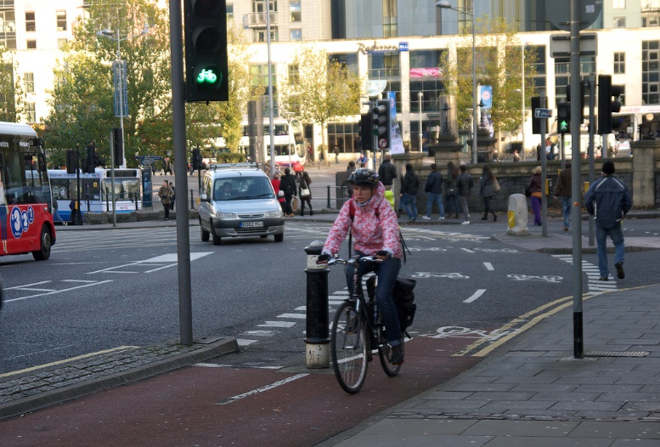
For more information about BCyC’s Road Justice campaigning see www.bristolcyclingcampaign.org.uk /campaign/road-justice
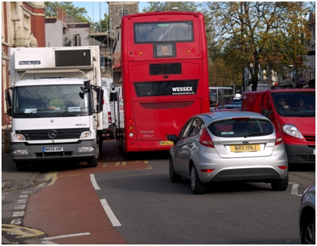
Photo courtesy of samsaundersleeds used under ShareAlike
Photo courtesy of Rob Harding
N

