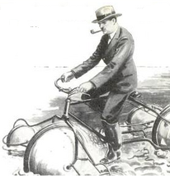  Don’t forget “there are few bridges” |  | G.H.S. Memorial Rides  Date – 14th April 2019  run by  Yorkshire Cycling Federation   |  |  | Don’t forget “there are few bridges”
£3.00 per rider on the line
Entries to – Mrs E Goodban, Sunset Bungalow, Bridge End, Rodley,
Leeds LS13 1LP
Tel – 0113 257 6023
I undertake to ride in a responsible manner and obey the rules of the road, I am covered by my own personal and third party insurance
Name | Address |  | Club | Distance |  | Place of start

