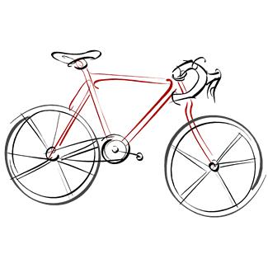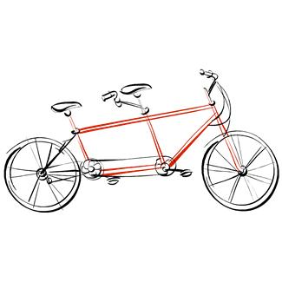

**Cyclebag East Ride Programme Autumn 2025**

**Chairman**.Sam Swaby Email albertswaby@sky.com

**Secretary.** Jo Hurst Email johurst@btinternet.com

**Treasurer.** Brian Baker Email brianalanbaker@hotmail.com

**Membership**. Patrick Birch Email patrick.birch@virginmedia.com

**Meeting Places**

Fishponds Fish. The fish structure on the Bristol rail path behind Morrisons at Fishponds

The Winterstream Farm Pub is at the junction of Winterbourne Road and Old Gloucester Road

The Pump House. Pub at the Hotwell Road end of the Harbourside.

Mangotsfield is at the Old Railway Station (Mangotsfield Station) on the Bristol to Bath cycle path.

Coxgrove Hill is where the Yate spur of the Bristol to Bath cycle path meets the bottom of Coxgrove Hill

|  |  |  |  |  |  |  |
| --- | --- | --- | --- | --- | --- | --- |
| **Day** | **Date** | **Leader** | **Area** | **Meet** | **Time** | **Miles** |
| Sat | 30th Aug | Kay | Wrington  Cycle festival way to Gatcombe cafe.  Then airport and Wrington for lunch.  There is a pub and cafe in Wrington, and good seating in the churchyard.  Return via Parsons at Backwell.  Probably 25-30 miles from and back to Pumphouse  Cancelled !!! |  |  |  |
| Sat | 6th Sept |  |  |  |  |  |
| Sat | 13th Sept | Chris W  and David W | Chew Valley  Festival Way to Gatcombe Farm for morning drinks  Barrow Gurney, Felton, and Winford Manor, Chew Stoke Salt and Malt on Chew Valley Lake for lunch    bring your own picnic, and/or buying hot and cold drinks, fish and chips, and other foodstuffs such as cake and various takeaway items.   After lunch Upper Stanton Drew, Pensford, and Compton Dando before climbing up and over Fairy Hill to Chewton Keynsham, refreshment break in Keynsham Memorial Park, at Baked Café   Head for Hicks Gate ring road cyclepath, through Hanham,descending to Conham River Park, and follow the river back to Netham Park and on to Pump House    This ride is fairly short but quite hilly, and so we will aim to go at a slow pace to compensate for the hills and to enjoy the company and the countryside. | The Pump House | 10am | 33 |
| Sat | 20th Sept | Dawn | Hawkesbury Upton / Hillesley  Via Badminton  Coffee at Hawkesbury shop on the green.  Picnic at Kingswood cemetery.  afternoon tea at The Bridge Cafe  Charfield. | Mangotsfield Old Station  Westerleigh lights | 10am  10.40ish | Under 40 miles |
|  |  |  |  |  |  |  |
| Sat | 27th Sept | Kay | Wrington  Cycle festival way to Gatcombe cafe.  Then airport and Wrington for lunch.  There is a pub and cafe in Wrington, and good seating in the churchyard.  Return via Parsons at Backwell.  Probably 25-30 miles from and back to Pumphouse  **Rescheduling Kays cancelled ride** | Pump House Pub | 10am | 25-30 return from start |
| Mon | 29th Sept  To  Friday 3rd Oct |  | Group caravan holiday in Barnstaple. |  |  |  |
| Sat | 4th Oct | Jo | ? Oldbury on Severn, Thornbury | Mangotsfield | 9.30am | TBC |
| Sat | 11th Oct | Patrick | Dundry | Fishponds Fish | 10am | Approx  23mile from Fish |
| Sat | 18th Oct |  |  |  |  |  |
| Sat | 25th Oct |  |  |  |  |  |
| Sat | 1st Nov |  |  |  |  |  |

Please wear bright clothing for your own protection

Please bring lights on all rides, as we can be delayed by punctures, or other unexpected events

Contact Jo with any queries 07941857644 , or by email CyclebagEast@outlook.com