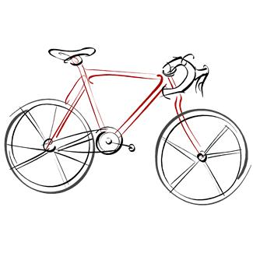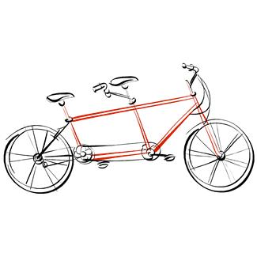

Cyclebag East Ride Programme

Chairman.Sam Swaby Email albertswaby@sky.com
Secretary. Jo Hurst Email johurst@btinternet.com
Treasurer. Brian Baker Email brianalanbaker@hotmail.com
Membership. Patrick Birch Email patrick.birch@virginmedia.com

Meeting Places
Fishponds Fish. The fish structure on the Bristol rail path behind Morrisons at Fishponds
The Winterstream Farm Pub is at the junction of Winterbourne Road and Old Gloucester Road
The Pump House. Pub at the Hotwell Road end of the Harbourside.
Mangotsfield is at the Old Railway Station (Mangotsfield Station) on the Bristol to Bath cycle path.
Coxgrove Hill is where the Yate spur of the Bristol to Bath cycle path meets the bottom of Coxgrove Hill

Day | Date | Leader | Area | Meet | Time | Miles
Sat | 25th Nov | Patrick | Stanton Prior Compton Dando | Mangotsfield | 10am | 25 miles
Sat | 2nd | Jo | Tortworth. Refreshments at The Hideout Lounge. | Mangotsfield | 10am | 30 miles from start
Sat | 9th^{h} | Mike | Rose and Crown Wick. Xmas lunch meet up.  Short ride around Golden Valley, Willsbridge and Doynton before arriving at the Rose and Crown in Wick. | Mangotsfield | 10am | 20 miles
Sat | 16th Dec | Geoff Carter | Backwell, Yatton  Refreshments Wetherspoons Nailsea. | Pump House | 10.30am | 25miles
Please wear bright clothing for your own protection
Please bring lights on all rides, as we can be delayed by punctures, or other unexpected events
Contact Jo with any queries 07941857644 , or by email CyclebagEast@outlook.com

