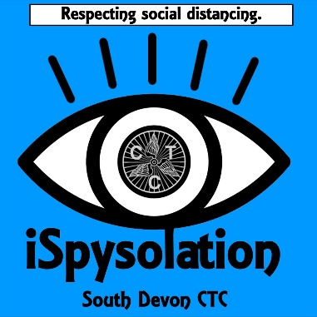

iSpysolation - the Isolated Cycling Scavenger Game by South Devon CTC
A new competition conceived and organised by South Devon CTC that is suited for lone cycling in uncrowded areas. The idea being to identify locations to ride to, past, or along and thereby claim your 'scavenge' of the features that are described. Use your local knowledge or maps to find locations, most of which we intend will be close enough to your homes to fit within your daily exercise. A total of 15 features are listed, you then cycle to as many as you can in the week, then a new list will be published the following week. Scoring, however, is based on a maximum of 3 scavenges per day, so that will require a minimum of five journeys in the week.
The rules to follow as below:
- One calendar week to complete, submitted responses by 9pm Wednesdays;
- New clues will be released between 9pm and 10pm on a Wednesday, with various members creating the lists;
- You can only claim each scavenge once in the week;
- Not more than three finds can be scavenged in a single day;
- Scoring: 1 scavenge in a day = 1 point, 2 = 3 points, 3 = 5 points;
- Honesty applies to scoring, though selfies and other form of evidence welcomed;
- At least one selfie to be provided at a clue and will be used for the announcement of the winner;
- Ride carefully and respectfully.

Note that this is aimed at you finding the clues in your own locality, avoiding populated areas and thereby respecting the lockdown whilst having a bit of fun and encourage regular exercise.
List for Week 1:
- A castle;
- A 5-way road junction;
- A finger post stating 5 miles to a town or village;
- A communications mast in the countryside;
- A yellow painted house;
- A road that is plumb straight for 1km;
- A road that climbs at least 100m;
- A bridge over the River Dart or one of its tributaries;
- A terrace of 4 or more thatched properties;
- A sign to a village of more than 10 letters;
- One single road crossing the same river or stream twice;
- A section of road that is higher than 150m;
- 1.6km or 1mile without retracing your route in which you neither climb nor descend more than 10m;
- A road that ends in the opposite direction to that in which it starts;
- A grass triangle formed by a road junction with a tree on it.

© South Devon CTC, part of Cycling UK

