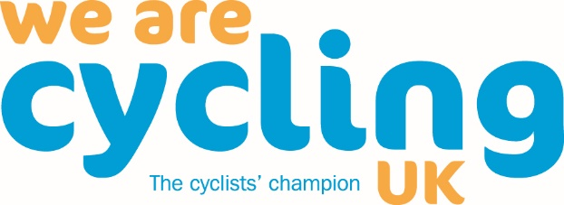

Members’ Motions to Cycling UK’s AGM, 13 June 2020

“The richness of all democratically-driven membership organisations lies in the thoughts, feelings and expectations of its members”.
Dan Howard, Chair of Cycling UK’s Board of Trustees.
This year we would like our AGM to help guide us on our campaigning priorities, how we might best market ourselves to prospective members, and how we develop programmes to help people to make cycling a part of their everyday life.
How you can help
As we head towards our 2020 AGM, our staff and Trustee teams are seeking motions from our members. With your help, we can make our next AGM a truly progressive and clear-minded debate about the future of cycling.
All we need from you, by 09.00am on the 14 February 2020, is the wording for your motion and a brief explanation giving the reason for your proposed motion. This must not exceed 200 words. Each Cycling UK member can submit a maximum of two motions at the AGM. Please use the form below to do this.
Then you as the ‘proposer’ of the motion just need the support of one other member to be the ‘seconder’ of your proposed motion. Finally, we’ll need you to join us at our AGM 13 June 2020 (venue and time to be confirmed) to put your motion forward for debate and a vote.
How we can help
As you are drafting your motion we’d really like to hear from you to learn more about your ideas and to offer our help and guidance. There is a limit to the number of resolutions which can be properly considered at the AGM. We sometimes receive suggestions for motions that:
- cover the same ground or are confusingly similar
- are contradictory
- appear to be based on a misunderstanding or lack of knowledge of the policy of Cycling UK, or
- are unclear.
We are keen to work with you to ensure that the AGM motions accurately reflect member concerns and help us ensure that the charity effectively achieves its aim of getting people cycling. (This may include airing issues where some members believe the charity’s policy should change.)
Please do get in touch with us via richard.walker@cyclinguk.org (include in the subject line “Draft AGM motion 2020”) or you can give us a call on 01483 238 304.
Proposer |  | Seconder
Full name |  | Full name
Membership Number |  | Membership Number
Signature |  | Signature
Your motion (max 200 words including the description of your motion):

Please post your signed, completed motion forms to Cycling UK, Parklands, Railton Road, Guildford Surrey, GU2 9JX (or you can email a copy to richard.walker@cyclinguk.org), to be received on or before 09.00am on the 14 February 2020.

