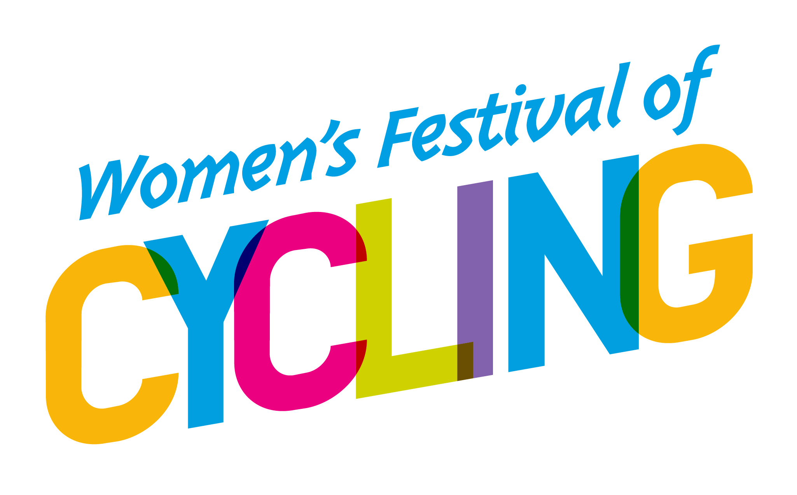Cycling UK Incident Report Form 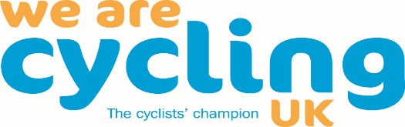

Did the incident happen during a group ride? Y/N  Group Name: | Name of person reporting incident:  Contact phone number:
Name of event organiser/ride leader:  Cycling UK Membership No if known: | Name of first party involved in incident:  Cycling UK Membership No if known:
Name of second party:  Cycling UK Membership No if known: | Date of incident:  Approximate location of incident
Collision with:

General description of incident:

Tick if a near-miss: [ ]
Severity of any injury: (please tick as appropriate)

Type of injury | Head | Torso | Limb
Fracture
Sprain
Cut
Burn
Bruise
Graze
Other

First party details of Cycling UK membership number not known:

Name: Address:

Phone no: Email:
Parents/Guardians/Next of kin contacted?

Name of person contacted: Relationship to injured party:

Contact phone number: Time of call:

Second party details:

Name: Address:

Phone no: Email:

Vehicle registration: Make/model: Colour:

Hospital details: Police details: Incident no:

Once completed, please email a copy of this form to:

- claims@butterworthspengler.co.uk
- carol.mckinley@cyclinguk.org
- groups@cyclinguk.org

If any of the parties thinks they may have a claim against another party, or they would like legal advice, they should also ring our Incident Claims Line on 0844 735 8452. Thank you.

