Procedure for ordering group branded Cycling UK clothing

The Cycling UK club jersey has been designed in such a way that it can accommodate your group or club name (depending on number of characters used). The overall design, layout and colour of the jersey cannot be changed and will remain the same.

The name of your group will feature under the Cycling UK logo in the ‘cocon font’ in the following positions (you don’t have to add your group name to all the positions if you don’t wish):

- Front (chest)
- Back (shoulders)
- Arm (left arm)
- Side (ribs)

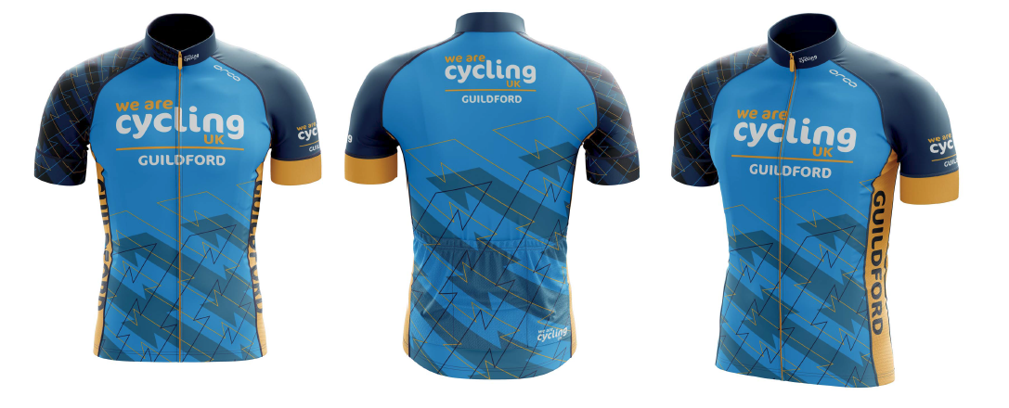

We’ve worked with Orca (who manufacture our jersey) to ensure they can produce small batch production runs. Groups and clubs only need to order a minimum of six jerseys per style (male & female are classed as different styles). The price of each jersey will remain at £50 and this includes the cost of artwork, VAT and delivery.

How to order your custom Cycling UK jersey:

- Email your group or club name to: shop@cyclinguk.org
- Visuals will be created and sent to you, giving you the opportunity to make updates and revisions if necessary. Once you’re happy with the artwork, Cycling UK will give final approval with Orca.
- Cycling UK will then upload the image onto your Cycling UK group page, which you can then share with the club members who can then order directly through shop@cyclinguk.org.
- Please be advised a good guide for delivery times is to allow 8 weeks from close of online store for delivery.

All information is correct at time of publication.

