Department for Transport and Active Travel England

Guidance on the provision and design of floating bus stops

Consultation response from Cycling UK

Cycling UK welcomes the opportunity to respond to this consultation.

Introduction – section 1
Cycling UK welcomes the emphasis in the introduction to the draft guidance on the importance of floating bus stops for keeping cyclists safe. It is important to note that many disabled people ride pedal cycles (including wider pedal-tricycles and adaptive bicycles) and use them as mobility aids, and therefore protected cycle lanes and floating bus stop infrastructure is key to keeping a wide variety of people safe and enabling them to cycle more.

We recommend including a wording change to a sentence in the second paragraph of the introduction. This is to show that without floating bus stops people riding bikes would be forced to move into the carriageway with potential for conflict with any motor vehicle (not just buses) at the bus stop.
‘Floating bus stops are primarily provided so that the continuity of cycle facilities can be maintained through bus stops, reducing the risk of cyclists coming into conflict with buses and other motor vehicles.’

Research – section 3
Cycling UK would like to see more research into the safety of floating bus stops which meet current LTN 1/20 standards vs those which don’t. We understand there are many examples of poor design which are putting pedestrians and disabled people at risk. This research would help in re-engineering non-compliant floating bus stops and bringing them up to a higher standard.

Engagement – section 4
Cycling UK agrees that cycling groups should be consulted by local authorities early in the design stage. The draft guidance says that ‘Designers should undergo training in disability needs and inclusive design.’ We recommend that designers also undergo cycle training or training into the needs of cyclists to ensure that they understand the risks posed when cycling on roads and on cycle track and shared use paths.

Assessment process – section 6
This section includes 10 key principles. We recommend including a principle whereby design of floating bus stops and the environment around them is fit for the future, i.e. for the growing number of cyclists predicted to use cycle tracks in the future. This is especially important as well-designed cycle tracks and new cycle routes will increase cycling rates and government policy is to increase cycling numbers.

Key design principle 3 states ‘No bus passenger should be expected to board or alight a bus into the direct path of a cyclist.’ We agree with this in most cases but not all. We agree with this principle where floating bus stops are next to cycle tracks and cycle lanes BUT we would like to see the guidance clarify that this principle is not applied to bus stops which are adjacent to shared use paths where there are very low levels of cycling. Our reasoning is explained in the section below on shared-use bus boarders. We recommend amending the draft principle to read the following or similar - ‘No bus passenger should be expected to board or alight a bus from a cycle track or cycle lane.’

Design options – section 7
Standard bus stop with no treatment

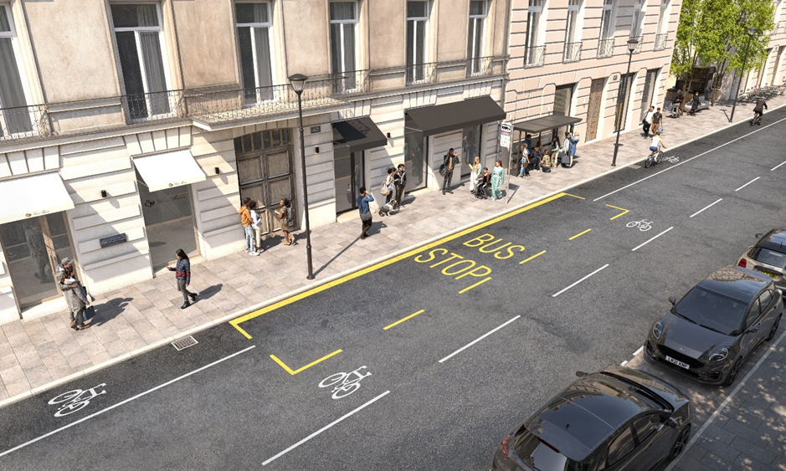
Cycling UK recognises that in some situations a bus stop bypass (to the rear of the bus stop) may not be possible. In this situation, every action to keep cyclists safe must be considered and put in place, as appropriate.

We have concerns with the detail of the information in the draft guidance and the image included in the draft guidance. The image shows a cycle lane (rather than cycle track) ending abruptly at the bus stop with cycle repeater markings to the right-hand side of the bus stop markings on the road. This indicates that if a bus is in the bus stop cyclists are expected to pass the bus to its right. This requires cyclists to move into the carriageway and into the traffic from left to right, presenting increased safety risk. We believe that the guidance could be improved as follows:
The guidance should:
  - Indicate that this situation may be needed to interrupt both cycle tracks and cycle lanes.
  - Not be used for a bi-directional cycle track.
  - Recommend that speed limits are lowered to 20mph in the vicinity of the bus stop to reduce vehicle speeds and improve safety.
  - Require coloured tarmac or coloured paint with dashed white lines and cycle markings for the full route around the bus stop – see image below which is Figure 6.24 from LTN 1/20 and is included to protect cyclists passing parking spaces or loading bays.

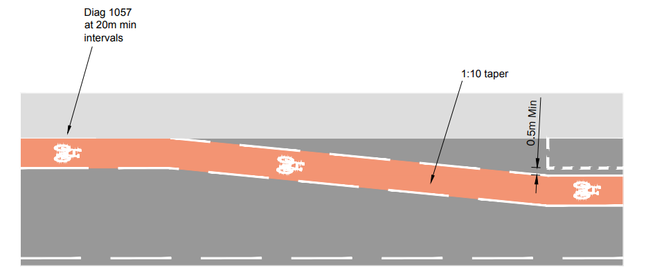

These additions are important to give cyclist confidence and for motorists to understand very clearly that the cycle lane/track is passing a bus stop and they need to be aware.

Shared-use bus boarders
We agree that in general shared-use bus boarders should not be used but there is one important exception. There needs to be more clarity in the guidance that shared-use bus boarders can mean pedestrians sharing space with a variety of cycling infrastructure, i.e.:
- Cycle tracks
- Cycle lanes
- Share use paths

We agree that bus stop boarders should not be included in the guidance where they apply to cycle tracks or cycle lanes, i.e. bus users should not have to cross a cycle track or cycle lane and use it to board or alight from the bus. We agree that this presents too much danger to pedestrian and cyclist.

We recommend that shared-use bus stop boarders are included in the guidance where they are located next to shared use paths with very low cycle volumes. Cycling UK’s position is that shared use paths are rarely satisfactory and should only be used where cycling volumes are low. Where possible different transport modes should be separated and have their own space. This means keeping pedestrians and wheelers separate from cyclists.

There are likely to be situations at bus stops where people need to cross and board or alight from busy shared use paths. This is in no way ideal and we believe that in these cases the shared use path may not be appropriate and a protected cycle track should be created.

The exception which we believe is necessary for the safety of cyclists is for bus stop boarders on shared use paths where volumes are very low. These shared use paths are often adjacent to busy roads, for example ring roads, but cycle volumes are very low. In such cases a shared-use bus stop boarder would be appropriate for the guidance. This does not, however, negate the need for signage or design which makes cyclists aware of and minimises the likelihood of potential conflict with pedestrians at bus stops on shared use paths.

This example is an exception to the principle 3 in the draft guidance and therefore principle 3 should be amended.

Behaviour change – section 8
We agree that more needs to be done to educate people about how to use floating bus stops. This includes raising awareness amongst cyclists of the need to slow down near floating bus stops and to stop when a pedestrian is waiting to cross a zebra – even if there are no yellow globes.

