**CTC Response to the Transport Committee’s Inquiry into Road Traffic Law Enforcement.**

**Introduction**

1. CTC, the national cycling charity, was founded in 1878 and has 68,000 members and supporters. CTC’s central mission is to make cycling a safe, accessible, enjoyable and ‘normal’ activity for people of all ages and abilities. Our interests cover cycling both as a form of day-to-day transport and as a leisure activity, which can deliver health, economic, environmental, safety and quality of life benefits both for individuals and society. We represent the interests of current and would-be cyclists on public policy matters, as well as organising projects to enable diverse people (including those from disadvantaged groups) to discover the benefits and joys of cycling. We organise cycling events and provide a range of information and legal services.
2. CTC has given oral evidence to a number of parliamentary inquiries in recent years, including the Commons Transport Committee’s inquiry on the Government’s road safety strategy[1], a more recent inquiry on Cycle safety[2], and the 2013 ‘Get Britain Cycling’ inquiry[3] conducted by the All Party Parliamentary Cycling Group (APPCG, which CTC supports along with its allies in the Active Travel Alliance). We strongly endorsed the inquiry’s 18 recommendations[4], which led the Government to propose a draft Cycling Delivery Plan. Our campaigning then helped secure cross-party backing for a legal commitment to a Cycling and Walking Investment Strategy, which was written into the Infrastructure Act 2015.
3. CTC welcomes the Government’s commitment to “reduce the number of cyclists and other road users killed or injured on our roads every year.”[5] CTC’s Road Justice Campaign ([www.roadjustice.org.uk](http://www.roadjustice.org.uk)) seeks to ensure the legal system acts as an effective deterrent to bad driving, thereby improving road safety for all road users, and for cyclists in particular.

**Road Safety for vulnerable road users**

1. The Department for Transport’s (DfT) recently released figures[6] show that total road deaths in 2014 increased by 4% compared with 2013. Cyclists’ deaths followed the same pattern rising from 109 to 113. The number of seriously injured cyclists however increased by 8.2% to 3401, whilst serious injuries to all road users only increased by 5%. With the exception of 2012/13 the number of seriously injured cyclists has now increased every year since a low of 2,174 in 2004.
2. Despite the fact that less than 2% of journeys inn Britain are made by cycle[7], cyclists represented 6.4% of the road fatalities in 2014 and 14.9% of the serious injuries. With 446 pedestrian deaths in 2014 (an 11.2% increase), cyclists and pedestrians accounted for 31.5% of the road fatalities, showing that when collisions with motor vehicles do occur cyclists and pedestrians are the vulnerable road users (VRU) who are disproportionately the victims.
3. CTC is particularly concerned that the risk of serious injury or death from cycling is increasing rather than decreasing, and that the risks to VRU appear to have increased as enforcement has declined. The risk per mile travelled of a serious cycling injury has now increased each year since 2007 and the risk of cycling remains higher in the UK than in other European countries, including Netherlands and Denmark where cycling use is ten times higher than in the UK. This may explain why 61% of people in the UK think that the UK roads are too dangerous to cycle on, with fatal and serious cycling casualties up 39% from the 2005 – 2009 average. It is vital that road traffic law enforcement is co-ordinated to tackle bad driving and driving behaviour, to reduce both risk and the fears that deter people from cycling (or allowing their children to do so), and in order to maximise cycling’s health, economic, environmental and other benefits.

**Police Road Traffic Officer numbers**

1. CTC’s Road Justice campaign has for several years highlighted the fact that roads policing has suffered disproportionate cuts compared with overall police numbers, and the possibility that this may explain (at least partly) the figures / trends outlined at paras 4-6 above. Traffic police officer numbers fell by 37% from 2002/3-2013/14, from almost 7,000 uniformed officers down to just 4,356. During that same period, total policing levels fluctuated little from year to year, but not to this degree: police officers in March 2014 numbered about 3.5% less than in 2003.[8] Roads policing is a highly effective road safety measure and the behaviour of motorists is directly affected by their perception of the enforcement of roads policing. In France a zero tolerance policy over speeding offences, and substantial investment in safety cameras and road traffic policing, saw road deaths drop by 43% between 2001 and 2007, with 45% of French drivers saying that ‘fear of punishment’ made them change their behaviour. This awareness of enforcement actions and consequences is also apparent from breath tests for alcohol / drugs, where fewer tests undertaken leads to increased drink drive casualties and more people driving over the limit . Further evidence of the effectiveness of roads policing is provided by our campaigns briefing on road traffic law and enforcement[9]. Put simply there is less fear of being caught and less driver behaviour change when there is a less visible and pro-active roads policing policy.
2. By 2013 only 3.6% of the total police force in England and Wales was dedicated to road traffic policing. This is partly a consequence of national policy decisions which discourages Chief Constables from prioritising resources for road crime reduction. Firstly the Association of Chief Police Officers has warned that the government’s refusal to include casualty related targets within its Road Safety strategy, which CTC campaigned for, has weakened the priority given to roads policing by individual forces. Secondly the Strategic Policy requirement[10] for the police focuses upon terrorism, organised crime, public disorder etc, but does not mention roads policing. Consequently decisions about how much priority is given to roads policing are made locally by Chief Constables facing budget restrictions. Including roads policing within the Strategic Policy requirement and in all overarching policy strategies and plans would enable individual police forces and Police Commissioners to prioritise roads policing.

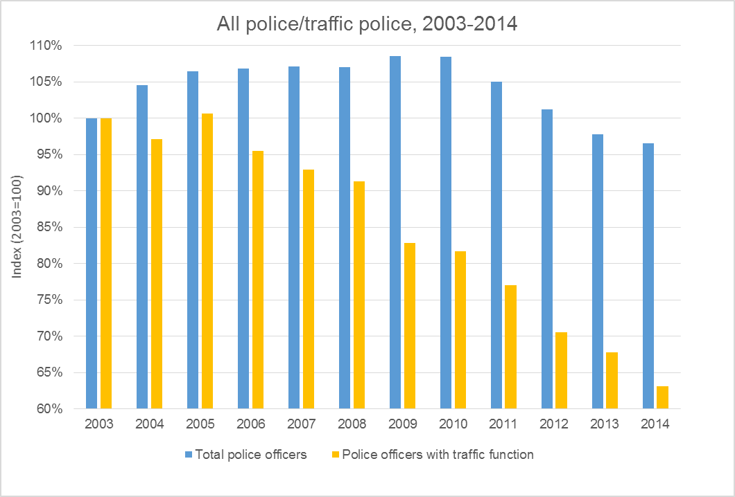

Changes in police numbers 2003 – 2014

1. The 2013 Get Britain Cycling Report[11] by the APPCG[12] called for better traffic law enforcement to encourage more people to cycle. That requires adequate resourcing of enforcement agencies. Regular reports are made to CTC within its Road Justice Campaign concerning the limitations upon police investigations of offences, which many police officers candidly and openly acknowledge. The mother of a 17 year old CTC member involved in an incident involving a motorist received an e-mail from the investigating police officer, typical of many, stating that ‘the police are as disappointed as you that we can only provide a very limited service to the public with the number of officers and budget available to us’. Limited resources inevitably impacts upon the ability of the police to properly investigate potential offences, including checking possible CCTV footage and examining mobile phones of drivers to check for mobile phone use at the time of the incident. Police resources also appear to have impacted upon their ability to investigate dangerous driving incidents. In 2014 the police recorded 59% fewer dangerous driving crimes than in 2002/03, despite the injury and fatality statistics suggesting that there was no corresponding improvement in driving standards / behaviour during that period.

**Police near miss and collision reporting**

1. CTC supports the implementation of collision and near miss reporting systems by police forces. Some individual police forces already implement such on-line systems, and follow up on-line reports regarding bad driving variously by correspondence to registered owners, visits to drivers, or referrals to DVLA. This can assist in identifying bad drivers and dangerous locations that would benefit from remedial attention. CTC believes this is a necessary element of a visible roads policing policy.

**Driving at work and the role of the Health and Safety Executive**

1. Whilst the police are the primary enforcement agency dealing with roads safety, CTC believes that other agencies, including the Health and Safety Executive (HSE), need to take a greater role in safety related enforcement. Approximately 25% of all road casualties in the UK involve a driver who is at work at the time (or their passenger). In 2013, the most recent year for which data are available, of 515 reported road deaths in GB involving a driver/rider driving for work, 400 (78%) were neither the driver nor one of their passengers. A further 219 deaths were reported in road traffic collisions involving a driver/rider commuting to or from work, of whom 94 were not the driver/rider or their passenger.[13]In the first six months of 2015 eight cyclists died in road traffic incidents within London. Seven of those deaths involved lorries and by definition a professional driver in the course of their employment. The remit of the HSE extends to work related work safety however its activities are limited to giving guidance. Enforcement activity is absent, presumably due to the resources this would require. Making those resources available would however have substantial road safety benefits. Given the statistics regarding injuries and fatalities involving professional drivers, and the specific risk presented to cyclists by lorries, effective enforcement involving professional drivers must involve both robust guidance and enforcement by the HSE.

**System for notification of the Traffic Commissioner and resourcing**

1. The stated mission of the Transport Commissioner (TC) is ‘to champion safe, fair and reliable passenger and goods transport’. In their 2014 /15 annual report one of their strategic objectives was said to be ‘to concentrate resources on regulating those drivers and operators who pose the greatest risk to road safety’. CTC believes their role in delivering this HGV and PSV licensing regime is severely compromised by the absence of an adequate and robust system of notification to the TC of incidents which may indicate safety failings by operators in order that they can be expeditiously investigated.
2. Currently there is no formal system / process for the police to provide details of traffic offences by or issues of concern regarding HGV drivers / operators to the TC. The implications of this were particularly evident in two recent cases involving cyclist’s fatalities which CTC investigated in the past year[14]. Both involved cyclists killed by lorries whose operators had previously come to the attention of the TC, but who managed to continue operating under different names, with unsafe drivers and with fatal consequences. In both cases there was also substantial delay in notification being given to the TC. In one case TfL notified the TC shortly after a lorry driver was sentenced for causing the death of the cyclist by careless driving 18 months previously. Once notified the TC promptly commenced an inquiry and both transport managers subsequently had their licences to operate revoked after it was found that they had failed to carry out due diligence checks to establish that the driver was qualified to drive their vehicles. In the interim however the company had continued to operate without appropriate vetting systems. In the other case CTC recently notified the TC of the death of two cyclists in an incident involving a HGV driver, in July 2013, where the driver has now been convicted of causing death by dangerous driving. Again the company has continued to operate in the interim.
3. To ensure that the TC is notified of all instances of potentially unsafe HGV drivers and operators, a formal reporting mechanism is required. CTC believes this should require both the police and DVSA to notify the TC of operators of vehicles involved in serious incidents or fatal collisions.
4. Enabling the TC to effectively fulfil their role will also require additional resources. It is nevertheless a safety critical role given the levels of non-compliant vehicles on our roads. During a recent crackdown by the TfL funded Commercial Vehicle, particular vehicles / operators were targeted for checks by the Unit. Three out of four lorries stopped were non-compliant in one or more construction or regulatory requirement.
5. Another way of driving up lorry operator’s standards, particularly within the construction industry (whose vehicles are disproportionately involved in the death of cyclists), would be to publicise their Operators Compliance Risk Scores (OCRS). Currently the DVSA collate the OCRS regarding vehicle / operator compliance (from routine stops / checks etc) yet this safety related information is not available for example to local authorities and other employers sub-contracting to haulage companies. If the OCRS were publically disclosed, major contractors would be able and encouraged in terms of their own vicarious liability, to consider the OCRS when awarding contracts, potentially driving out rogue operators.

**Disqualifications, sanctions and fixed penalty notices**

1. Fixed penalty notices (FPN’s) were introduced in August 2013 for careless driving offences. However CTC is concerned that police forces are making increased use of driver training or speed awareness courses as alternatives to prosecution and the imposition of penalty points. This in turn reduces the number of unsafe drivers taken off the roads. The number of driving disqualifications has reduced by 47% since 2007 even though the number of fatal or serious injuries has only fallen by 17.4% in the same period.

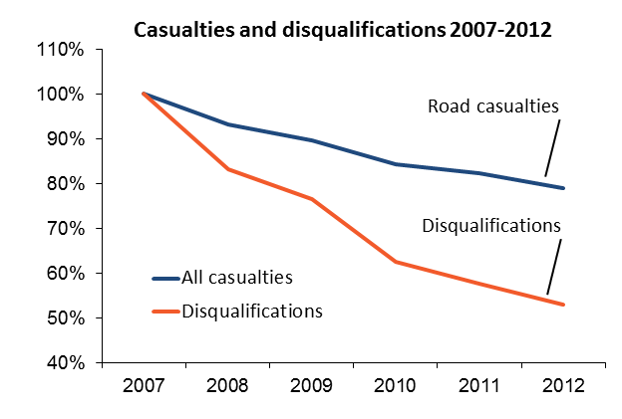

1. CTC is also concerned at the number of drivers who do not face disqualification despite reaching or surpassing the 12 point limit. Alarmingly, as risk increases, fewer drivers are being taken off the road as a consequence of their bad driving. This is unlikely to be as a consequence of any major improvement in driving standards as in 2014, for the 10th consecutive year, ‘failing to look properly’ was the most common contributory factor in road collisions. In May 2013 63% of drivers with more than 12 points on their licence avoided disqualification, presumably either because they successfully argued exceptional hardship to escape disqualification when appearing at court, or because they avoided any court appearance which may have led to disqualification as the latter points were fixed penalty points not entailing any court attendance. Driving disqualifications had already reduced by 37.6% between 2009 and 2013[15] prior to the new FPN system for careless driving being introduced. In 2012 only 1 in 37 drivers convicted of careless driving were disqualified for the offence itself. Since 2013 the courts are now unable to impose points or consider disqualification in the 72% of careless driving incidents where drivers are diverted to remedial courses, further reducing the likelihood of disqualification for bad driving.
2. The FPN system for careless driving operates through drivers being given a conditional fixed penalty notice, with many of those drivers then being offered the opportunity to attend an NDAC (National Driver Awareness Course) in lieu of a fine or incurring penalty points. Driver retraining, speed awareness and similar courses are an important and growing source or revenue to police forces. In 2014 over 1.35 million drivers attended various remedial courses provided through the National Driver Offender Retraining Scheme as an alternative to prosecution. 1,185,860 people attended the National Speed Awareness Course (NSAC) and 21,272 the NDAC, an increase in the year to August 2014 (the first year of FPN’s for careless driving). The course provider will have an overhead cost but at an average fee of £100 for a NSAC and £150 for a NDAC, and with The FPN system for careless driving operates through drivers being given a conditional fixed penalty notice, with many of those drivers then being offered the opportunity to attend an NDAC (National Driver Awareness Course) in lieu of a fine or incurring penalty points. 1.35 million courses being run each year, a huge amount of revenue is diverted from the Lord Chancellor’s Department via potential court fines (which could be earmarked towards road safety enforcement), and directed instead towards a rapidly growing remedial driving industry.
3. There is however no evidence that such diversionary training works in changing driver behaviour and improving road safety. Research into the effect of retraining courses on re-offending rates of drivers reported for careless driving was carried out by the Transport Research Laboratory (TRL Broughton et al))[16] in 2005. The finding was that such schemes had no detectable impact on re-offending rates, which perhaps not surprisingly accords with the evidence from France that drivers amend their behaviour in fear of prosecution and a zero tolerance approach (para 7 above). By contrast another TRL study[17](Broughton 2008) showed that drivers close to 12 points on their licence modified their behaviour to avoid losing their licences.
4. There are no national statistics available regarding the percentage of drivers receiving FPN’s who were subsequently offered the opportunity to attend an NDAC (and avoid penalty points), as each police force compiles their own statistics. However Freedom of information requests have revealed that four police forces (Nottingham, West Mercia, Kent and West Yorkshire) issued a total of 1901 FPN’s for either careless or inconsiderate driving in the year to August 2014. 381 (72.8%) of those drivers had either attended or been offered the opportunity to attend an NDAC. If that represents the national trend (as CTC suspects), it would validate the concerns expressed by CTC prior to the implementation of the new FPN system that driver training courses of doubtful effectiveness could end up being used instead of a more effective sanction and penalty points.
5. CTC believes that the overuse of remedial training as an option following the issuing of FPN’s for careless driving is undermining the gravity of that offence and reducing the likelihood of bad drivers being disqualified as a consequence of their driving. There is also a generic problem with the overuse of remedial courses generally, which contributes to the perception that road traffic crime is not ‘real crime’. This links with the points previously made regarding the priority given to road traffic policing. If it is not given priority by central government as part of the Strategic Policy it is not surprising that Chief Constables allocate resources elsewhere in preference to roads policing. If this leads to a less visible roads policing policy, with police forces effectively given an incentive to offer remedial courses rather than prosecute, reducing the fear of prosecution and disqualification, it is unsurprising that some motorists do not perceive motoring offences to be ‘real crime’. None of this assists in the creation either of an effective enforcement policy or in improving road safety.

**CTC, the national cycling charity. 12th October 2015**

1. See [www.ctc.org.uk/news/2012-07-17/road-safety-inquiry-highlights-lack-of-government-leadership-on-cycling](http://www.ctc.org.uk/news/2012-07-17/road-safety-inquiry-highlights-lack-of-government-leadership-on-cycling)
2. See [www.ctc.org.uk/news/ctc-urges-mps-to-demand-action-and-funding-to-‘get-britain-cycling](http://www.ctc.org.uk/news/ctc-urges-mps-to-demand-action-and-funding-to-'get-britain-cycling)’
3. See [www.ctc.org.uk/get-britain-cycling](http://www.ctc.org.uk/get-britain-cycling) and [www.ctc.org.uk/ministers-police-and-jon-snow-appear-appcg](http://www.ctc.org.uk/ministers-police-and-jon-snow-appear-appcg)
4. See [www.ctc.org.uk/news/get-britain-cycling-report-recommends-%C2%A310-head-year-funding-for-cycling](http://www.ctc.org.uk/news/get-britain-cycling-report-recommends-%C2%A310-head-year-funding-for-cycling)
5. See p15 <https://s3-eu-west-1.amazonaws.com/manifesto2015/ConservativeManifesto2015.pdf>
6. See <https://www.gov.uk/government/statistics/reported-road-casualties-great-britain-annual-report-2014>
7. See <https://www.gov.uk/government/statistics/national-travel-survey-2013>
8. Home Office (2015). *Police workforce, England and Wales, 30 September 2014*, table 6: [www.gov.uk/government/statistics/police-workforce-england-and-wales-30-september-2014-data-tables](http://www.gov.uk/government/statistics/police-workforce-england-and-wales-30-september-2014-data-tables)
9. See <http://www.ctc.org.uk/sites/default/files/file_public/traffic-law-enforcementoverview4brv2.pdf>
10. See <https://www.gov.uk/government/publications/strategic-policing-requirement>
11. See <https://allpartycycling.files.wordpress.com/2013/04/get-britain-cycling1.pdf>
12. See <http://allpartycycling.org/>
13. See <https://www.gov.uk/government/uploads/system/uploads/attachment_data/file/10180/ras30037.xls>
14. See <http://www.ctc.org.uk/news/20150608-reining-rogue-goods-vehicle-operators>
15. See Ministry of Justice monitoring tables 2013 <https://www.gov.uk/government/statistics/criminal-justice-statistics-quarterly-december-2013>
16. See <http://www.trl.co.uk/reports-publications/trl-reports/report/?reportid=5364>
17. See <http://www.trl.co.uk/reports-publications/trl-reports/report/?reportid=6386>