Private

courses
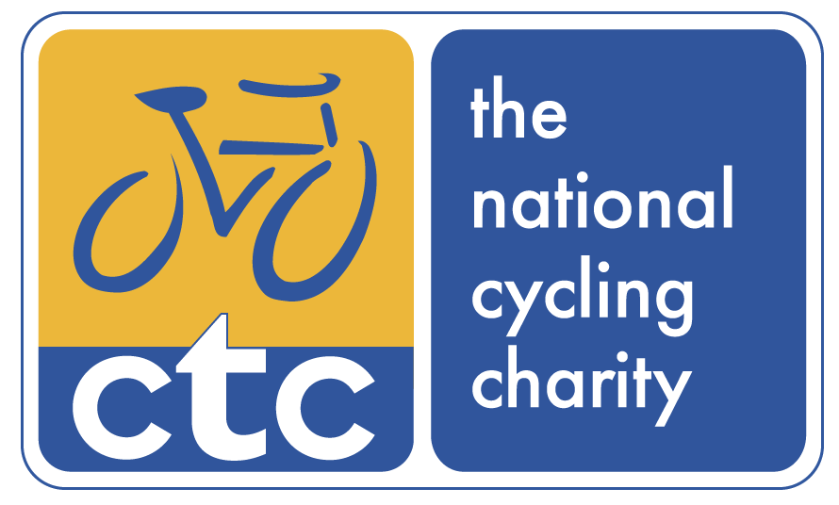

CTC Education
62-68 Thirlwell Road, Sheffield, S8 9TF

Tel: 0844 736 8463
Email: mtb@ctc.org.uk
www.ctc.org.uk/education
Private Courses
Process
Information Pack

Introduction
This document outlines the process and procedures in the setting up of a private course for your group. General course details, content and scheme outlines are available at http://www.ctc.org.uk/courses-training

Over half of all CTC courses are private courses, which we provide throughout the UK and Europe via our team of specialist Leader Trainers.

All private courses fulfill the requirements of the National Assessment Criteria, but they can be tailored within boundaries to suit the circumstances of the delegates working environments

Process to Private Courses
- You return an expression of interest form, which doesn't hold you to having a course, but identifies some preliminary factors we both require.
- Together, we identify suitable location for riding and classroom activities.
- CTC will send you a booking confirmation to detail these factors, which you sign and return with a purchase order.
- CTC dates, times, venue and trainers are confirmed. We issue a final confirmation for you.
- Delegates call the booking line to reserve their place and receive confirmation and pre-course information by email.
- Invoice issued.
- Your course runs.
- Invoice is paid.
- Course reviewed and delegates certificates issued.
This is demonstrated graphically over

Outline working arrangements
CTC provide the pre-course information, the course itself and course follow up. This includes for the trainer, course resources and supporting information as well as certificates and individual reviews.
You need to provide a suitable venue, classroom and AV equipment. Where transport is required, you or the delegates will also be required to provide this.
Delegates need to provide bikes and riding equipment.

Further information and expression of interest
- General course information;
- Private course information, including numbers and costs;
- Private course expression of interest form to get the ball rolling without any commitment at this stage.

For any further information, please contact us.

Diagrammatic Process to Private Courses
8) Your invoice is paid
7) Your course runs
6) CTC issues your invoice
9) Course is reviewed and certificates issued
5) Delegates call the booking line to confirm their place and are issued pre-course information
3) CTC send a booking confirmation for you to check, sign and return
4) Course details and trainers are confirmed in final confirmation
2) Discuss with CTC Training the venue and local riding requirements
- Complete and return an expression of interest form

